Digital Signal Processing

Audio Equalizer

Final Project

Amr Mohamad Salah – 6287

Mohamed Ayman Sallam – 6144

Hazem Shaaban – 6328

Code:

%----------------------------AUDIO EQUALIZER---------------------------------

flag=0;

%Take file name from the user

prompt = 'Please enter the file name: ';

x = input(prompt,'s');

[y,Fs]=audioread(x);

disp('----------------------------------------');

%Get gain from the user

disp('Please enter the gain:');

g1 = input('enter gain 1 (0-170 Hz): ');

g2 = input('enter gain 2 (170-310 Hz): ');

g3 = input('enter gain 3 (310-600 Hz): ');

g4 = input('enter gain 4 (600-1000 Hz): ');

g5 = input('enter gain 5 (1-3 KHz): ');

g6 = input('enter gain 6 (3-6 KHz): ');

g7 = input('enter gain 7 (6-12 KHz): ');

g8 = input('enter gain 8 (12-14 KHz): ');

g9 = input('enter gain 9 (14-16 KHz): ');

disp('----------------------------------------');

%Get sample rate from the user

Fstest= input('Enter the output Sample Rate: ');

if Fstest > 32000

Fsout=Fstest;

else

Fsout=34000;

flag=1;

end

disp('----------------------------------------');

fm=Fsout/2;

%Get type of filter from the user

while(1)

disp('Choose the type of filter: ');

disp('1)IIR Filter 2)FIR Filter');

filterType = input('Please Enter your choice: ');

disp('----------------------------------------');

switch filterType

case 1

N = 2;

%-----------------------------IIR Filters---------------------------

% -----------(0-170 Hz)------------

Wc1 = 170/(fm); % normalize the cutoff frequency

[num1,den1] = butter(N,Wc1); % get the num and den

[z1,p1,k1] = butter(N,Wc1); % get zeros , poles , gain

transferFunc1=tf(num1,den1); % get the transfer function

[H1,w1] = freqz(num1,den1); % compute the frequency response

mag1 = abs(H1); % compute the magnitude

phase1 = angle(H1)*180/pi; % compute the phase

% -------Plotting------

subplot(4,1,1);plot(w1/pi,mag1);grid;xlim([0 1]);title('Magnitude');

subplot(4,1,2);plot(w1/pi,phase1);grid;xlim([0 0.1]);title('Phase');

subplot(4,1,3);stem(impulse(transferFunc1));grid;title('Impulse Response');

subplot(4,1,4);stem(step(transferFunc1));grid;title('Step Response');

suptitle('0-170 Hz');

figure; pzmap(transferFunc1);title('Zeros and poles of (0-170 Hz)');

% ------------(170-310 Hz)---------------

Wc21=170;

Wc22=310;

Wc2 = [Wc21 Wc22]/(fm); % normalize the cutoff frequency

[num2,den2] = butter(N,Wc2); % get the num and den

[z2,p2,k2] = butter(N,Wc2); % get zeros , poles , gain

transferFunc2=tf(num2,den2); % get the transfer function

[H2,w2] = freqz(num2,den2); % compute the frequency response

mag2 = abs(H2); % compute the magnitude

phase2 = angle(H2)*180/pi; % compute the phase

% -------Plotting------

figure;

subplot(4,1,1);plot(w2/pi,mag2);grid;xlim([0 1]);title('Magnitude');

subplot(4,1,2);plot(w2/pi,phase2);grid;xlim([0 0.1]);title('Phase');

subplot(4,1,3);stem(impulse(transferFunc2));grid;title('Impulse Response');

subplot(4,1,4);stem(step(transferFunc2));grid;title('Step Response');

suptitle('170-310 Hz');

figure; pzmap(transferFunc2);title('Zeros and poles of (170-310 Hz)');

% --------------(310-600 Hz)---------------

Wc31=310;

Wc32=600;

Wc3 = [Wc31 Wc32]/(fm); % normalize the cutoff frequency

[num3,den3] = butter(N,Wc3); % get the num and den

[z3,p3,k3] = butter(N,Wc3); % get zeros , poles , gain

transferFunc3=tf(num3,den3); % get the transfer function

[H3,w3] = freqz(num3,den3); % compute the frequency response

mag3 = abs(H3); % compute the magnitude

phase3 = angle(H3)*180/pi; % compute the phase

% -------Plotting------

figure;

subplot(4,1,1);plot(w3/pi,mag3);grid;xlim([0 1]);title('Magnitude');

subplot(4,1,2);plot(w3/pi,phase3);grid;xlim([0 0.1]);title('Phase');

subplot(4,1,3);stem(impulse(transferFunc3));grid;title('Impulse Response');

subplot(4,1,4);stem(step(transferFunc3));grid;title('Step Response');

suptitle('310-600 Hz');

figure; pzmap(transferFunc3);title('Zeros and poles of (310-600 Hz)');

% --------------(600-1000 Hz)---------------

Wc41=600;

Wc42=1000;

Wc4 = [Wc41 Wc42]/(fm); % normalize the cutoff frequency

[num4,den4] = butter(N,Wc4); % get the num and den

[z4,p4,k4] = butter(N,Wc4); % get zeros , poles , gain

transferFunc4=tf(num4,den4); % get the transfer function

[H4,w4] = freqz(num4,den4); % compute the frequency response

mag4 = abs(H4); % compute the magnitude

phase4 = angle(H4)*180/pi; % compute the phase

% -------Plotting------

figure;

subplot(4,1,1);plot(w4/pi,mag4);grid;xlim([0 1]);title('Magnitude');

subplot(4,1,2);plot(w4/pi,phase4);grid;xlim([0 0.1]);title('Phase');

subplot(4,1,3);stem(impulse(transferFunc4));grid;title('Impulse Response');

subplot(4,1,4);stem(step(transferFunc4));grid;title('Step Response');

suptitle('600-1000 Hz');

figure; pzmap(transferFunc4);title('Zeros and poles of (600-1000 Hz)');

% --------------(1000-3000 Hz)---------------

Wc51=1000;

Wc52=3000;

Wc5= [Wc51 Wc52]/(fm); % normalize the cutoff frequency

[num5,den5] = butter(N,Wc5); % get the num and den

[z5,p5,k5] = butter(N,Wc5); % get zeros , poles , gain

transferFunc5=tf(num5,den5); % get the transfer function

[H5,w5] = freqz(num5,den5); % compute the frequency response

mag5 = abs(H5); % compute the magniutde

phase5 = angle(H5)*180/pi; % compute the phase

% -------Plotting------

figure;

subplot(4,1,1);plot(w5/pi,mag5);grid;xlim([0 1]);title('Magnitude');

subplot(4,1,2);plot(w5/pi,phase5);grid;xlim([0 0.1]);title('Phase');

subplot(4,1,3);stem(impulse(transferFunc5));grid;title('Impulse Response');

subplot(4,1,4);stem(step(transferFunc5));grid;title('Step Response');

suptitle('1000-3000 Hz');

figure; pzmap(transferFunc5);title('Zeros and poles of (1000-3000 Hz)');

% --------------(3000-6000 Hz)---------------

Wc61=3000;

Wc62=6000;

Wc6= [Wc61 Wc62]/(fm); % normalize the cutoff frequency

[num6,den6] = butter(N,Wc6); % get the num and den

[z6,p6,k6] = butter(N,Wc6); % get zeros , poles , gain

transferFunc6=tf(num6,den6); % get the transfer function

[H6,w6] = freqz(num6,den6); % compute the frequency response

mag6 = abs(H6); % compute the magnitude

phase6 = angle(H6)*180/pi; % compute the phase

% -------Plotting------

figure;

subplot(4,1,1);plot(w6/pi,mag6);grid;xlim([0 1]);title('Magnitude');

subplot(4,1,2);plot(w6/pi,phase6);grid;xlim([0 0.1]);title('Phase');

subplot(4,1,3);stem(impulse(transferFunc6));grid;title('Impulse Response');

subplot(4,1,4);stem(step(transferFunc6));grid;title('Step Response');

suptitle('3000-6000 Hz');

figure; pzmap(transferFunc6);title('Zeros and poles of (3000-6000 Hz)');

%------------(6000-12000 Hz)---------------

Wc71=6000;

Wc72=12000;

Wc7= [Wc71 Wc72]/(fm); % normalize the cutoff frequency

[num7,den7] = butter(N,Wc7); % get the num and den

[z7,p7,k7] = butter(N,Wc7); % get zeros , poles , gain

transferFunc7=tf(num7,den7); % get the transfer function

[H7,w7] = freqz(num7,den7); % compute the frequency response

mag7 = abs(H7); % compute the magnitude

phase7 = angle(H7)*180/pi; % compute the phase

% -------Plotting------

figure;

subplot(4,1,1);plot(w7/pi,mag7);grid;xlim([0 1]);title('Magnitude');

subplot(4,1,2);plot(w7/pi,phase7);grid;xlim([0 0.1]);title('Phase');

subplot(4,1,3);stem(impulse(transferFunc7));grid;title('Impulse Response');

subplot(4,1,4);stem(step(transferFunc7));grid;title('Step Response');

suptitle('6000-12000 Hz');

figure; pzmap(transferFunc7);title('Zeros and poles of (6000-12000 Hz)');

% --------------(12000-14000 Hz)---------------

Wc81=12000;

Wc82=14000;

Wc8= [Wc81 Wc82]/(fm); % normalize the cutoff frequency

[num8,den8] = butter(N,Wc8); % get the num and den

[z8,p8,k8] = butter(N,Wc8); % get zeros , poles , gain

transferFunc8=tf(num8,den8); % get the transfer function

[H8,w8] = freqz(num8,den8); % compute the frequency response

mag8 = abs(H8); % compute the magnitude

phase8 = angle(H8)*180/pi; % compute the phase

% -------Plotting------

figure;

subplot(4,1,1);plot(w8/pi,mag8);grid;xlim([0 1]);title('Magnitude');

subplot(4,1,2);plot(w8/pi,phase8);grid;xlim([0 0.1]);title('Phase');

subplot(4,1,3);stem(impulse(transferFunc8));grid;title('Impulse Response');

subplot(4,1,4);stem(step(transferFunc8));grid;title('Step Response');

suptitle('12000-14000 Hz');

figure; pzmap(transferFunc8);title('Zeros and poles of (12000-14000 Hz)');

% -------------(14000-16000 Hz)---------------

Wc91=14000;

Wc92=16000;

Wc9= [Wc91 Wc92]/(fm); % normalize the cutoff frequency

[num9,den9] = butter(N,Wc9); % get the num and den

[z9,p9,k9] = butter(N,Wc9); % get zeros , poles , gain

transferFunc9=tf(num9,den9); % get the transfer function

[H9,w9] = freqz(num9,den9); % compute the frequency response

mag9 = abs(H9); % compute the magnitude

phase9 = angle(H9)*180/pi; % compute the phase

% -------Plotting------

figure;

subplot(4,1,1);plot(w9/pi,mag9);grid;xlim([0 1]);title('Magnitude');

subplot(4,1,2);plot(w9/pi,phase9);grid;xlim([0 0.1]);title('Phase');

subplot(4,1,3);stem(impulse(transferFunc9));grid;title('Impulse Response');

subplot(4,1,4);stem(step(transferFunc9));grid;title('Step Response');

suptitle('14000-16000 Hz');

figure; pzmap(transferFunc9);title('Zeros and poles of (14000-16000 Hz)');

break;

case 2

N = 300;

%----------------------FIR Filters-----------------------------

% -------------(0-170 Hz)--------------

Wc1=170/fm;

num1=fir1(N,Wc1); % get the numerator

den1=1;

transferFunc1=tf(num1,den1); % get the transfer function

[H1,w1] = freqz(num1,den1); % compute the frequency response

[H12,t11]=impz(num1,den1); % compute impulse response

[H13,t12]=stepz(num1,den1); % compute step response

mag1 = abs(H1); % compute the magnitude

phase1 = angle(H1)*180/pi; % compute the phase

% -------Plotting------

subplot(4,1,1);plot(w1/pi,mag1);grid;xlim([0 1]);title('Magnitude');

subplot(4,1,2);plot(w1/pi,phase1);grid;xlim([0 1]);title('Phase');

subplot(4,1,3);stem(t11,H12);grid;title('Impulse Response');

subplot(4,1,4);stem(t12,H13);grid;title('Step Response');

suptitle('0-170 Hz');

figure; pzmap(transferFunc1);title('Zeros and poles of (0-170 Hz)');

%----------(170-310 Hz)--------------

Wc21=170;

Wc22=310;

Wc2=[Wc21 Wc22]/fm;

num2=fir1(N,Wc2); % get the numerator

den2=1;

transferFunc2=tf(num2,den2); % get the transfer function

[H2,w2] = freqz(num2,den2); % compute the frequency response

[H22,t21]=impz(num2,den2); % compute impulse response

[H23,t22]=stepz(num2,den2); % compute step response

mag2 = abs(H2); % compute the magnitude

phase2 = angle(H2)*180/pi; % compute the phase

% -------Plotting------

figure;

subplot(4,1,1);plot(w2/pi,mag2);grid;xlim([0 1]);title('Magnitude');

subplot(4,1,2);plot(w2/pi,phase2);grid;xlim([0 1]);title('Phase');

subplot(4,1,3);stem(t21,H22);grid;title('Impulse Response');

subplot(4,1,4);stem(t22,H23);grid;title('Step Response');

suptitle('170-310 Hz');

figure; pzmap(transferFunc2);title('Zeros and poles of (170-310 Hz)');

% -------------(310-600 Hz)--------------

Wc31=310;

Wc32=600;

Wc3=[Wc31 Wc32]/fm;

num3=fir1(N,Wc3); % get the numerator

den3=1;

transferFunc3=tf(num3,den3); % get the transfer function

[H3,w3] = freqz(num3,den3); % compute the frequency response

[H32,t31]=impz(num3,den3); % compute impulse response

[H33,t32]=stepz(num3,den3); % compute step response

mag3 = abs(H3); % compute the magnitude

phase3 = angle(H3)*180/pi; % compute the phase

% -------Plotting------

figure;

subplot(4,1,1);plot(w3/pi,mag3);grid;xlim([0 1]);title('Magnitude');

subplot(4,1,2);plot(w3/pi,phase3);grid;xlim([0 1]);title('Phase');

subplot(4,1,3);stem(t31,H32);grid;title('Impulse Response');

subplot(4,1,4);stem(t32,H33);grid;title('Step Response');

suptitle('310-600 Hz');

figure; pzmap(transferFunc3);title('Zeros and poles of (310-600 Hz)');

% ------------(600-1000 Hz)--------------

Wc41=600;

Wc42=1000;

Wc4=[Wc41 Wc42]/fm;

num4=fir1(N,Wc4); % get the numerator

den4=1;

transferFunc4=tf(num4,den4); % get the transfer function

[H4,w4] = freqz(num4,den4); % compute the frequency response

[H42,t41]=impz(num4,den4); % compute impulse response

[H43,t42]=stepz(num4,den4); % compute step response

mag4 = abs(H4); % compute the magnitude

phase4 = angle(H4)*180/pi; % compute the phase

% -------Plotting------

figure;

subplot(4,1,1);plot(w4/pi,mag4);grid;xlim([0 1]);title('Magnitude');

subplot(4,1,2);plot(w4/pi,phase4);grid;xlim([0 1]);title('Phase');

subplot(4,1,3);stem(t41,H42);grid;title('Impulse Response');

subplot(4,1,4);stem(t42,H43);grid;title('Step Response');

suptitle('600-1000 Hz');

figure; pzmap(transferFunc4);title('Zeros and poles of (600-1000 Hz)');

% -------------(1000-3000 Hz)--------------

Wc51=1000;

Wc52=3000;

Wc5=[Wc51 Wc52]/fm;

num5=fir1(N,Wc5); % get the numerator

den5=1;

transferFunc5=tf(num5,den5); % get the transfer function

[H5,w5] = freqz(num5,den5); % compute the frequency response

[H52,t51]=impz(num5,den5); % compute impulse response

[H53,t52]=stepz(num5,den5); % compute step response

mag5 = abs(H5); % compute the magnitude

phase5 = angle(H5)*180/pi; % compute the phase

% -------Plotting------

figure;

subplot(4,1,1);plot(w5/pi,mag5);grid;xlim([0 1]);title('Magnitude');

subplot(4,1,2);plot(w5/pi,phase5);grid;xlim([0 1]);title('Phase');

subplot(4,1,3);stem(t51,H52);grid;title('Impulse Response');

subplot(4,1,4);stem(t52,H53);grid;title('Step Response');

suptitle('1000-3000 Hz');

figure; pzmap(transferFunc5);title('Zeros and poles of (1000-3000 Hz)');

% -------------(3000-6000 Hz)--------------

Wc61=3000;

Wc62=6000;

Wc6=[Wc61 Wc62]/fm;

num6=fir1(N,Wc6); % get the numerator

den6=1;

transferFunc6=tf(num6,den6); % get the transfer function

[H6,w6] = freqz(num6,den6); % compute the frequency response

[H62,t61]=impz(num6,den6); % compute impulse response

[H63,t62]=stepz(num6,den6); % compute step response

mag6 = abs(H6); % compute the magnitude

phase6 = angle(H6)*180/pi; % compute the phase

% -------Plotting------

figure;

subplot(4,1,1);plot(w6/pi,mag6);grid;xlim([0 1]);title('Magnitude');

subplot(4,1,2);plot(w6/pi,phase6);grid;xlim([0 1]);title('Phase');

subplot(4,1,3);stem(t61,H62);grid;title('Impulse Response');

subplot(4,1,4);stem(t62,H63);grid;title('Step Response');

suptitle('3000-6000 Hz');

figure; pzmap(transferFunc6);title('Zeros and poles of (3000-6000 Hz)');

% -------------(6000-12000 Hz)--------------

Wc71=6000;

Wc72=12000;

Wc7=[Wc71 Wc72]/fm;

num7=fir1(N,Wc7); % get the numerator

den7=1;

transferFunc7=tf(num7,den7); % get the transfer function

[H7,w7] = freqz(num7,den7); % compute the frequency response

[H72,t71]=impz(num7,den7); % compute impulse response

[H73,t72]=stepz(num7,den7); % compute step response

mag7 = abs(H7); % compute the magnitude

phase7 = angle(H7)*180/pi; % compute the phase

% -------Plotting------

figure;

subplot(4,1,1);plot(w7/pi,mag7);grid;xlim([0 1]);title('Magnitude');

subplot(4,1,2);plot(w7/pi,phase7);grid;xlim([0 1]);title('Phase');

subplot(4,1,3);stem(t71,H72);grid;title('Impulse Response');

subplot(4,1,4);stem(t72,H73);grid;title('Step Response');

suptitle('6000-12000 Hz');

figure; pzmap(transferFunc7);title('Zeros and poles of (6000-12000 Hz)');

% -------------(12000-14000 Hz)--------------

Wc81=12000;

Wc82=14000;

Wc8=[Wc81 Wc82]/fm;

num8=fir1(N,Wc8); % get the numerator

den8=1;

transferFunc8=tf(num8,den8); % get the transfer function

[H8,w8] = freqz(num8,den8); % compute the frequency response

[H82,t81]=impz(num8,den8); % compute impulse response

[H83,t82]=stepz(num8,den8); % compute step response

mag8 = abs(H8); % compute the magnitude

phase8 = angle(H8)*180/pi; % compute the phase

% -------Plotting------

figure;

subplot(4,1,1);plot(w8/pi,mag8);grid;xlim([0 1]);title('Magnitude');

subplot(4,1,2);plot(w8/pi,phase8);grid;xlim([0 1]);title('Phase');

subplot(4,1,3);stem(t81,H82);grid;title('Impulse Response');

subplot(4,1,4);stem(t82,H83);grid;title('Step Response');

suptitle('12000-14000 Hz');

figure; pzmap(transferFunc8);title('Zeros and poles of (12000-14000 Hz)');

% -------------(14000-16000 Hz)--------------

Wc91=14000;

Wc92=16000;

Wc9=[Wc91 Wc92]/fm;

num9=fir1(N,Wc9); % get the numerator

den9=1;

transferFunc9=tf(num9,den9); % get the transfer function

[H9,w9] = freqz(num9,den9); % compute the frequency response

[H92,t91]=impz(num9,den9); % compute impulse response

[H93,t92]=stepz(num9,den9); % compute step response

mag9 = abs(H9); % compute the magnitude

phase9 = angle(H9)*180/pi; % compute the phase

% -------Plotting------

figure;

subplot(4,1,1);plot(w9/pi,mag9);grid;xlim([0 1]);title('Magnitude');

subplot(4,1,2);plot(w9/pi,phase9);grid;xlim([0 1]);title('Phase');

subplot(4,1,3);stem(t91,H92);grid;title('Impulse Response');

subplot(4,1,4);stem(t92,H93);grid;title('Step Response');

suptitle('14000-16000 Hz');

figure; pzmap(transferFunc9);title('Zeros and poles of (14000-16000 Hz)');

break;

otherwise

disp('ERROR! PLEASE ENTER CORRECT NUMBER');

end

end

%Filtering the input sound

g1 = db2mag(g1);

f1=g1*filter(num1,den1,y);

F1=real(fft(f1));

g2 = db2mag(g2);

f2=g2*filter(num2,den2,y);

F2=real(fft(f2));

g3 = db2mag(g3);

f3=g3*filter(num3,den3,y);

F3=real(fft(f3));

g4 = db2mag(g4);

f4=g4*filter(num4,den4,y);

F4=real(fft(f4));

g5 = db2mag(g5);

f5=g5*filter(num5,den5,y);

F5=real(fft(f5));

g6 = db2mag(g6);

f6=g6*filter(num6,den6,y);

F6=real(fft(f6));

g7 = db2mag(g7);

f7=g7*filter(num7,den7,y);

F7=real(fft(f7));

g8 = db2mag(g8);

f8=g8*filter(num8,den8,y);

F8=real(fft(f8));

g9 = db2mag(g9);

f9=g9*filter(num9,den9,y);

F9=real(fft(f9));

%plotting output signal from filter(0-170)

figure;

subplot(2,1,1);plot(f1);grid;

title('Filtered signal in time domain');

subplot(2,1,2);plot(F1);grid;

title('Filtered signal in frequency domain');

suptitle('0- 170 Hz');

%plotting output signal from filter(170-310)

figure;

subplot(2,1,1);plot(f2);grid;

title('Filtered signal in time domain');

subplot(2,1,2);plot(F2);grid;

title('Filtered signal in frequency domain');

suptitle('170- 310 Hz');

%plotting output signal from filter(310-600)

figure;

subplot(2,1,1);plot(f3);grid;

title('Filtered signal in time domain');

subplot(2,1,2);plot(F3);grid;

title('Filtered signal in frequency domain');

suptitle('310- 600 Hz');

%plotting output signal from filter(600-1000)

figure;

subplot(2,1,1);plot(f4);grid;

title('Filtered signal in time domain');

subplot(2,1,2);plot(F4);grid;

title('Filtered signal in frequency domain');

suptitle('600- 1000 Hz');

%plotting output signal from filter(1000-3000)

figure;

subplot(2,1,1);plot(f5);grid;

title('Filtered signal in time domain');

subplot(2,1,2);plot(F5);grid;

title('Filtered signal in frequency domain');

suptitle('1000- 3000 Hz');

%plotting output signal from filter(3000-6000)

figure;

subplot(2,1,1);plot(f6);grid;

title('Filtered signal in time domain');

subplot(2,1,2);plot(F6);grid;

title('Filtered signal in frequency domain');

suptitle('3000- 6000 Hz');

%plotting output signal from filter(6000-12000)

figure;

subplot(2,1,1);plot(f7);grid;

title('Filtered signal in time domain');

subplot(2,1,2);plot(F7);grid;

title('Filtered signal in frequency domain');

suptitle('6000- 12000 Hz');

%plotting output signal from filter(12000-14000)

figure;

subplot(2,1,1);plot(f8);grid;

title('Filtered signal in time domain');

subplot(2,1,2);plot(F8);grid;

title('Filtered signal in frequency domain');

suptitle('12000- 14000 Hz');

%plotting output signal from filter(14000-16000)

figure;

subplot(2,1,1);plot(f9);grid;

title('Filtered signal in time domain');

subplot(2,1,2);plot(F9);grid;

title('Filtered signal in frequency domain');

suptitle('14000- 16000 Hz');

ftotal=f1+f2+f3+f4+f5+f6+f7+f8+f9;

Ftotal=real(fft(ftotal));

Y=real(fft(y));

%plotting output signal VS original signal

figure;

subplot(2,2,1);plot(y,'b');grid;

title('Original signal in time domain');

subplot(2,2,2);plot(Y,'b');grid;

title('Original signal in frequency domain');

subplot(2,2,3);plot(ftotal,'r');grid;

title('Filtered signal in time domain');

subplot(2,2,4);plot(Ftotal,'r');grid;

title('Filtered signal in frequency domain');

suptitle('Composite Signal VS Original Signal');

if flag==1

Fsout=Fstest;

end

sound(ftotal,Fsout);

Input Sound File Sampling Frequency = 44100 Hz

Program input Requirements:

* Sound File name.
* Gain of each frequency band in dB.
* Output Sampling Frequency.
* Type of filter (IIR or FIR).

Sample Runs:

-First sample run:

* Sound File name is ‘sound2.wav’
* Gain = 0 for first 7 bands and = 5 for last 2 bands
* Output Sampling Frequency = 22050
* Type of filter is ‘IIR Filter’

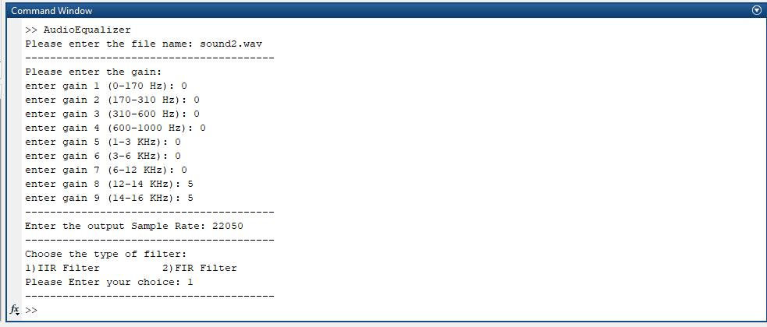

Analysis of each output and exported outputs

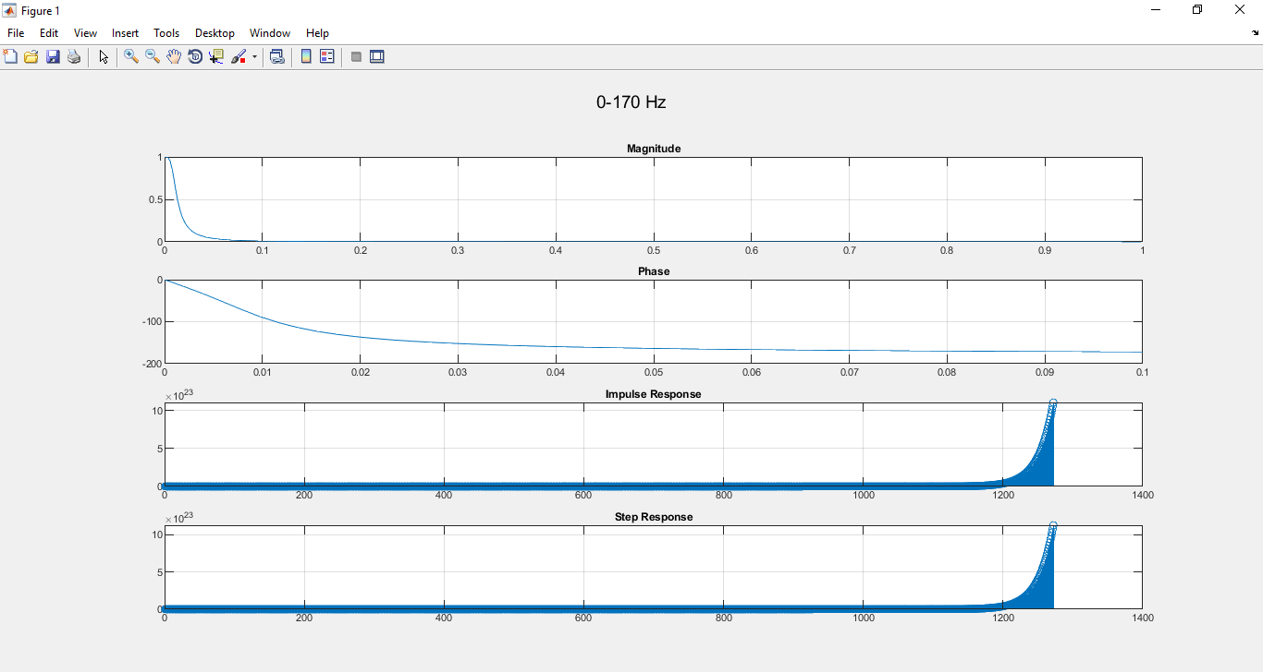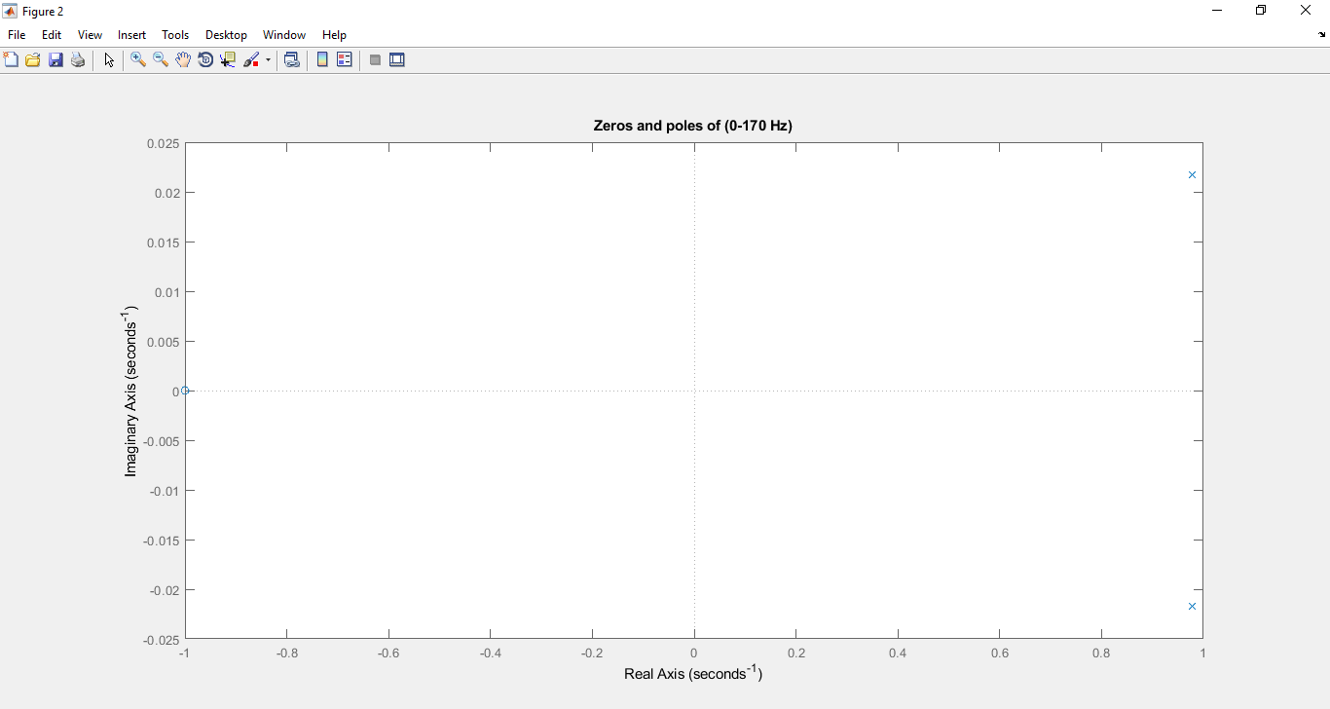First Band 0-170 Hz:

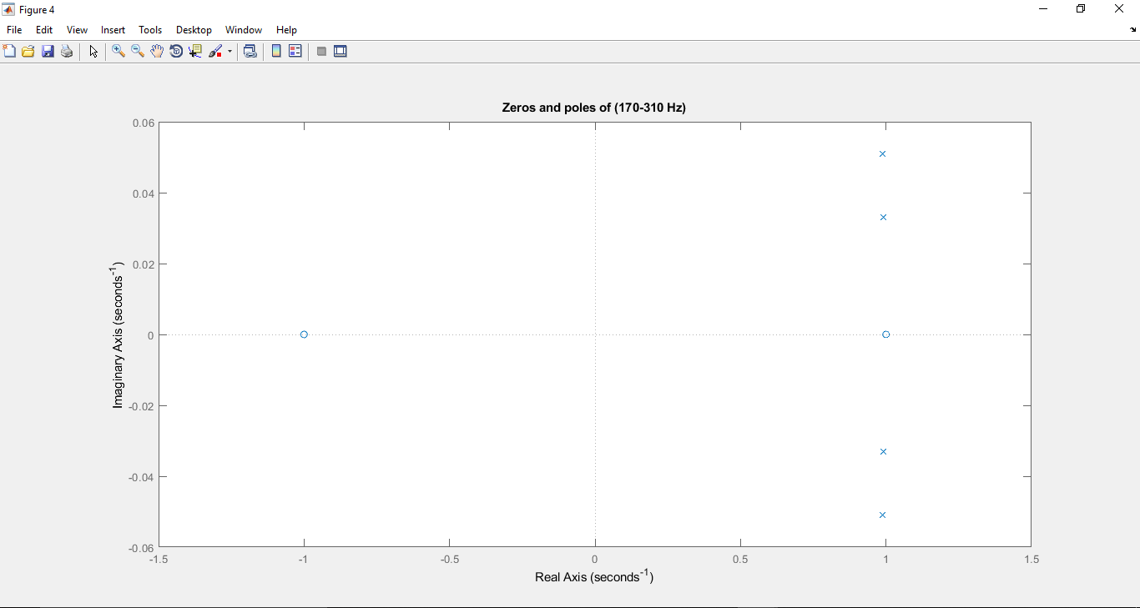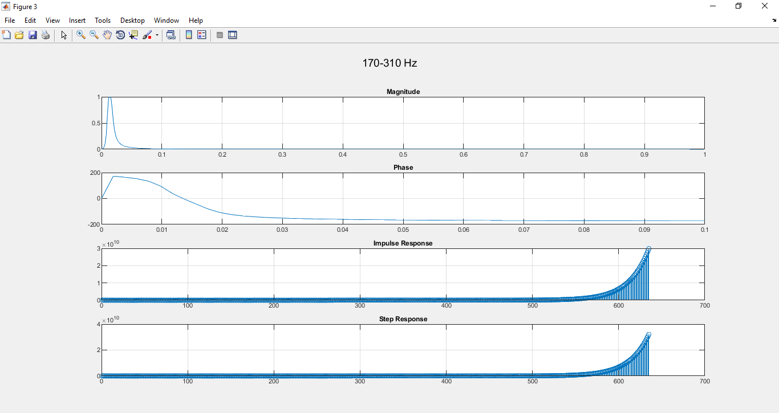Second Band 170-310 Hz:

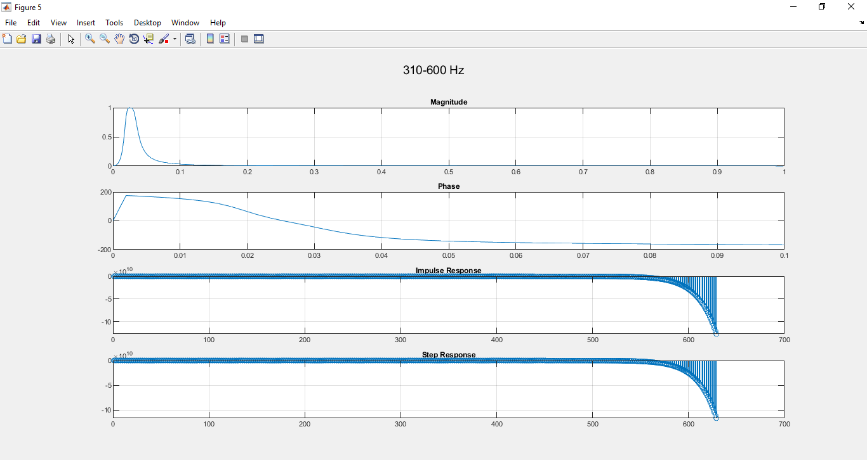Third Band 310-600 Hz:

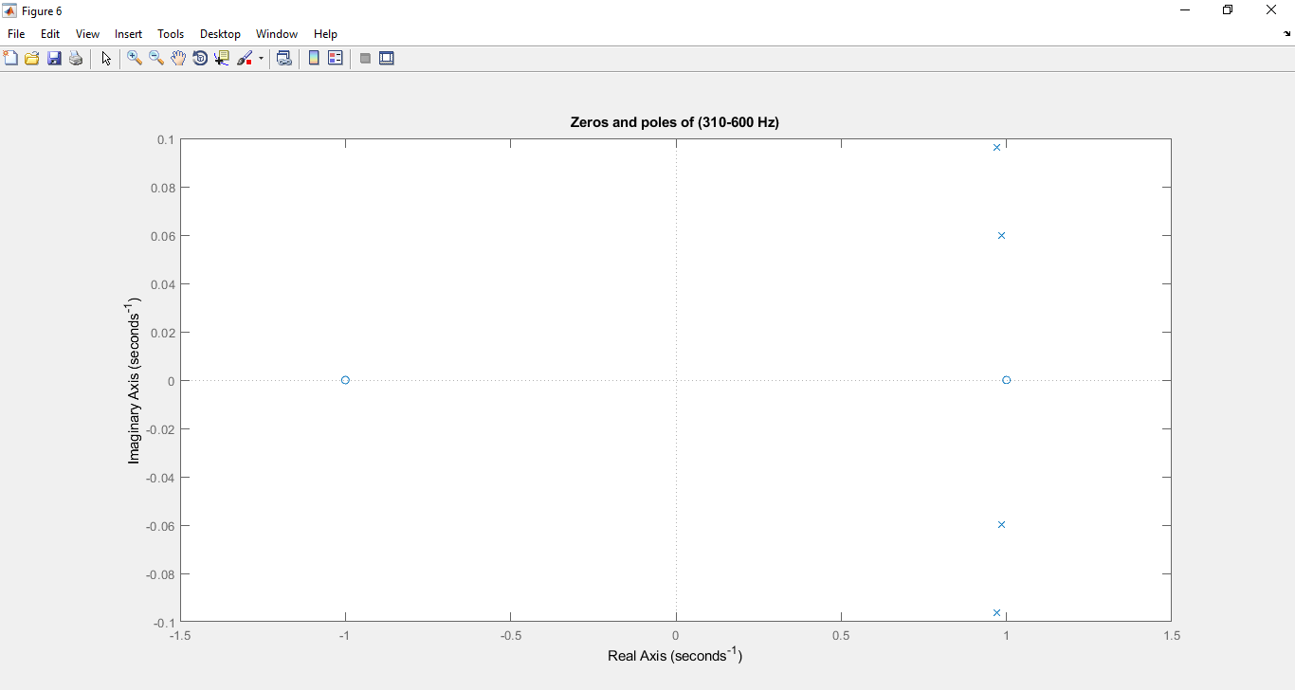

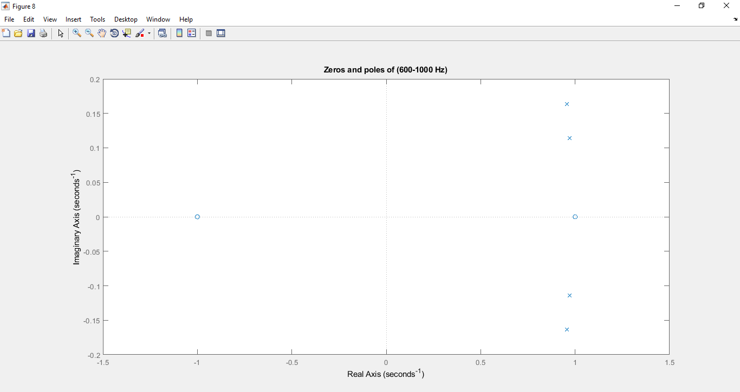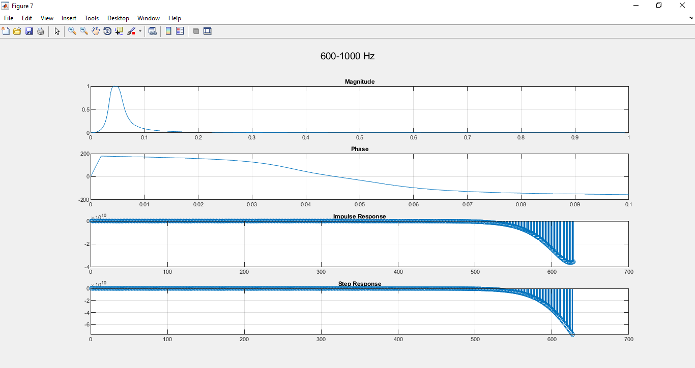 Fourth Band 600-1000 Hz:

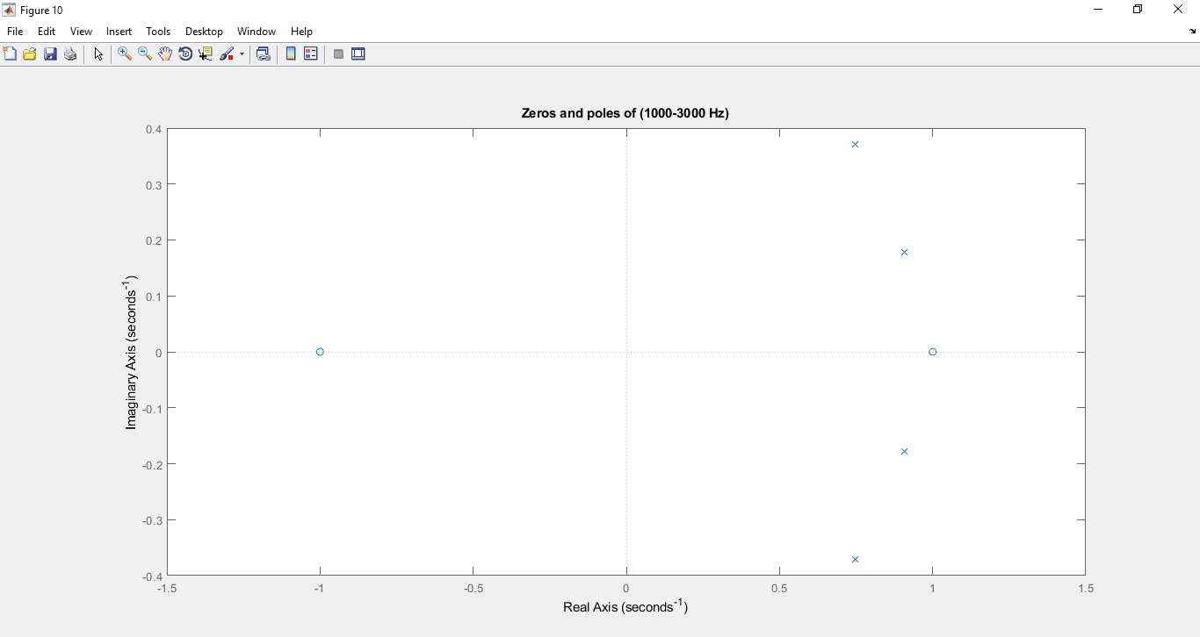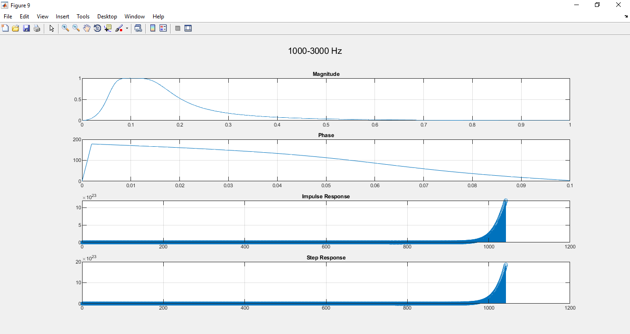Fifth Band 1000-3000 Hz:

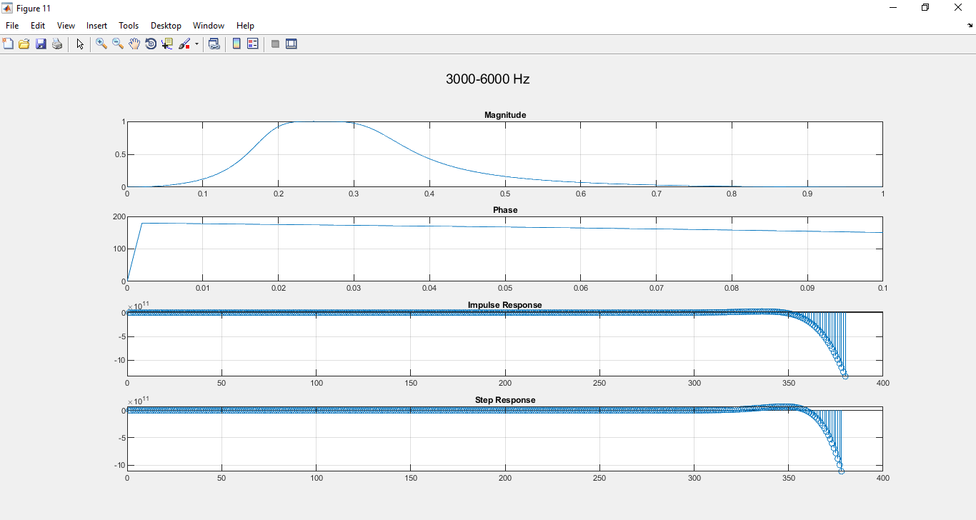Sixth Band 3000-6000 Hz:

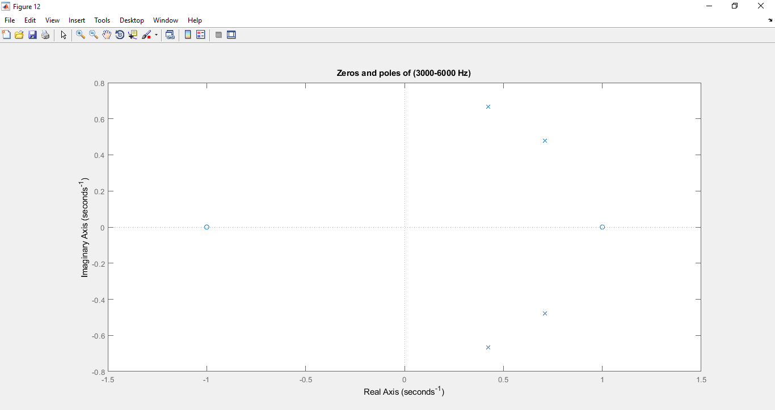

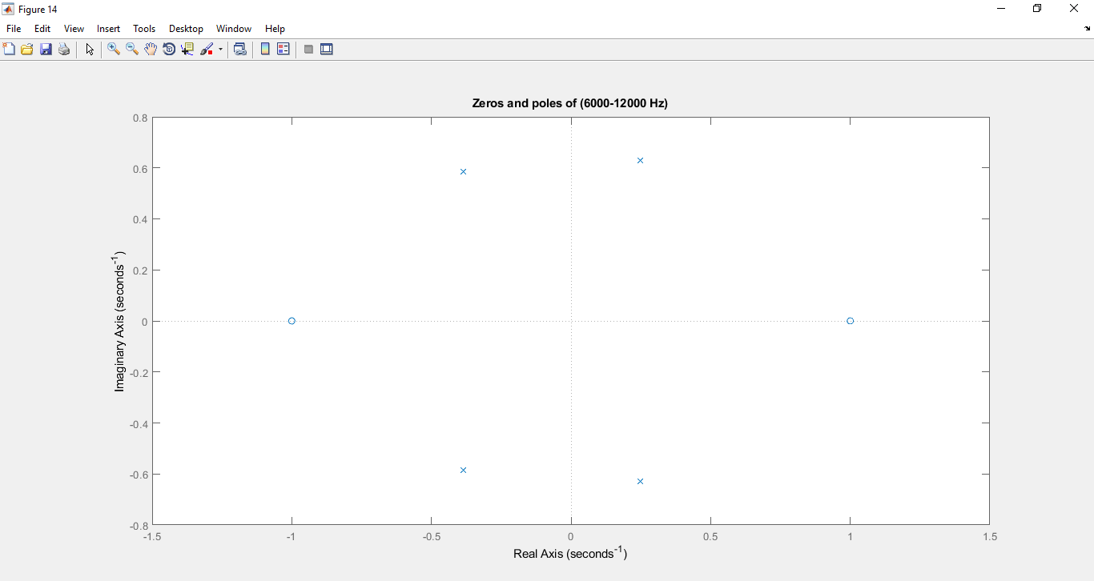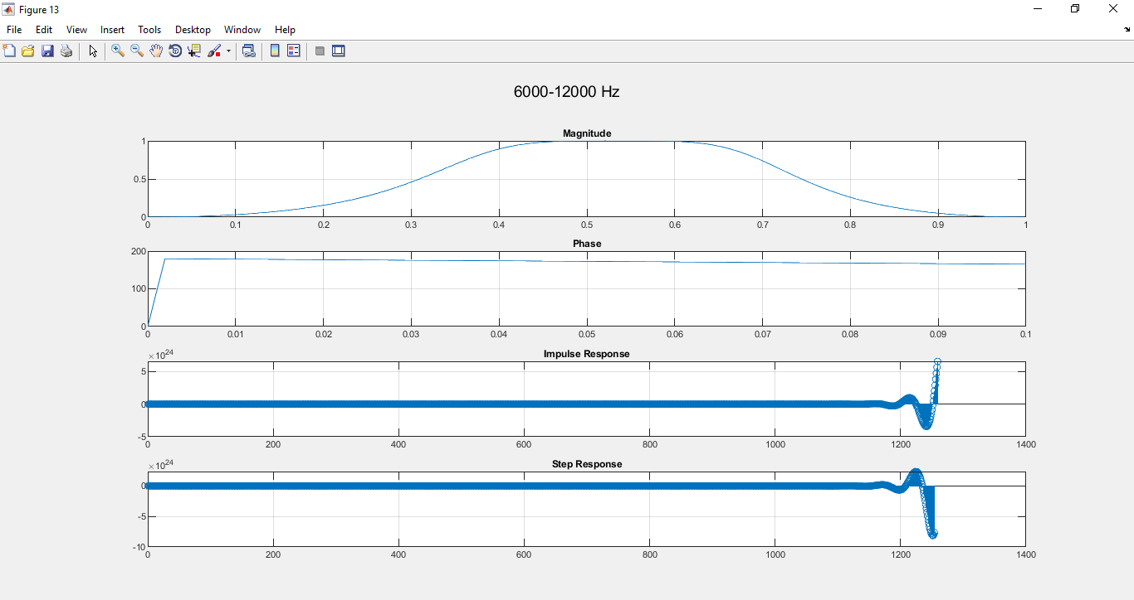Seventh Band 6000-12000 Hz:

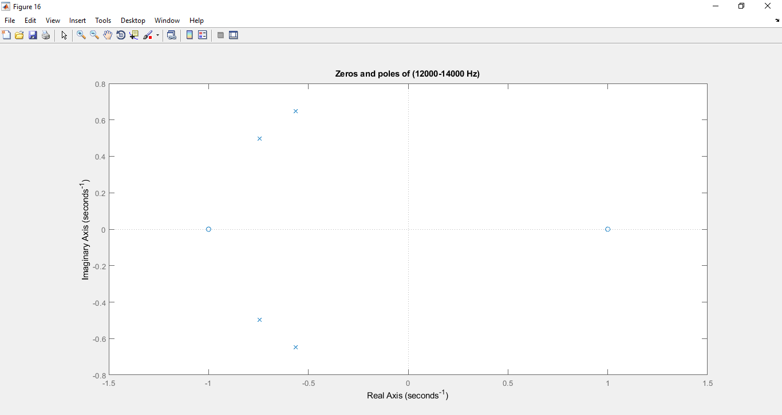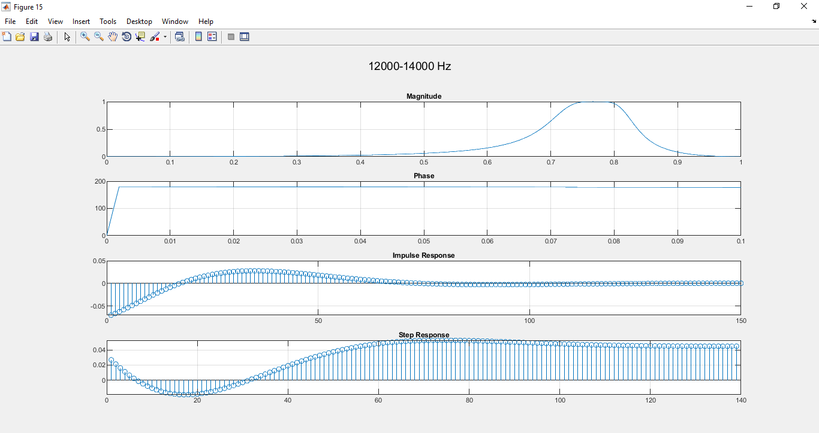Eighth Band 12000-14000 Hz:

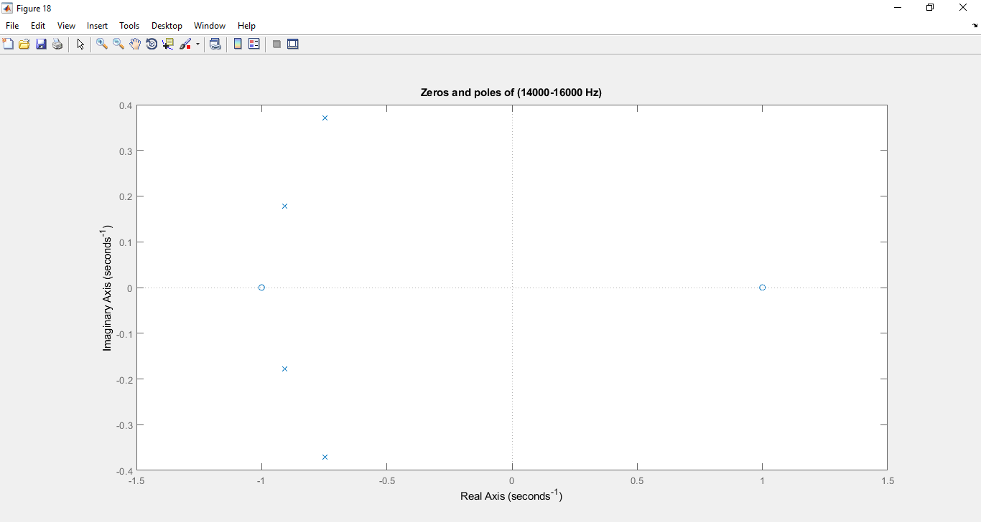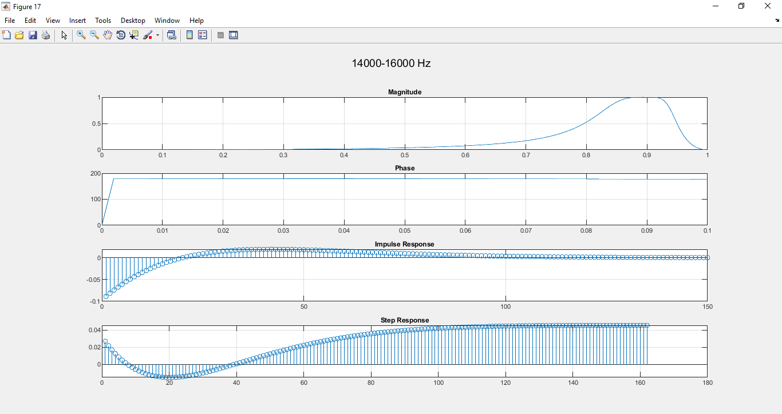Ninth Band 14000-16000 Hz:

All Signals in Frequency and Time Domain

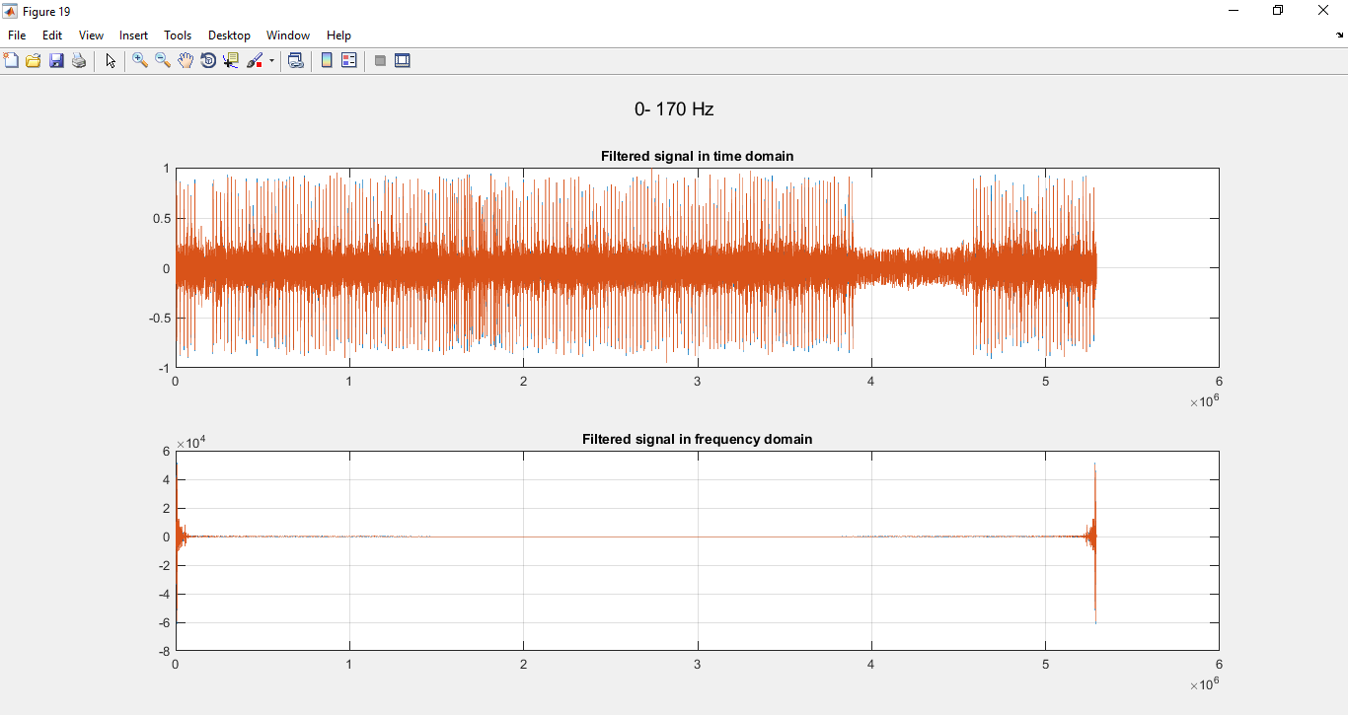First Band 0-170 Hz:

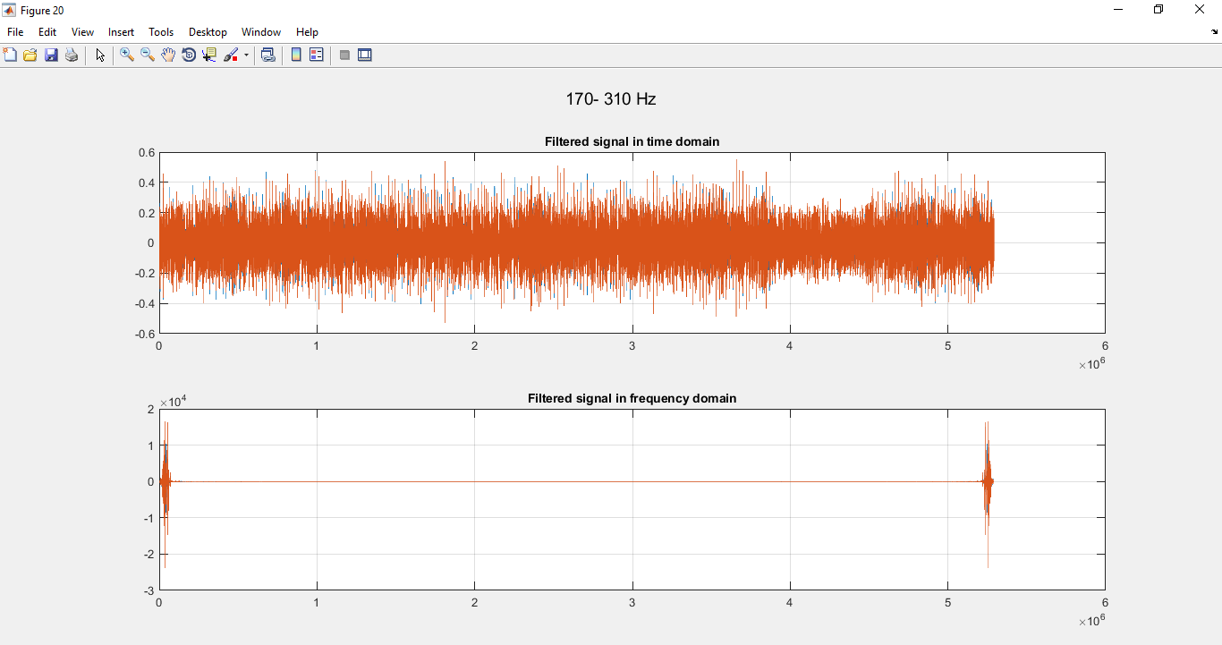Second Band 170-310 Hz:

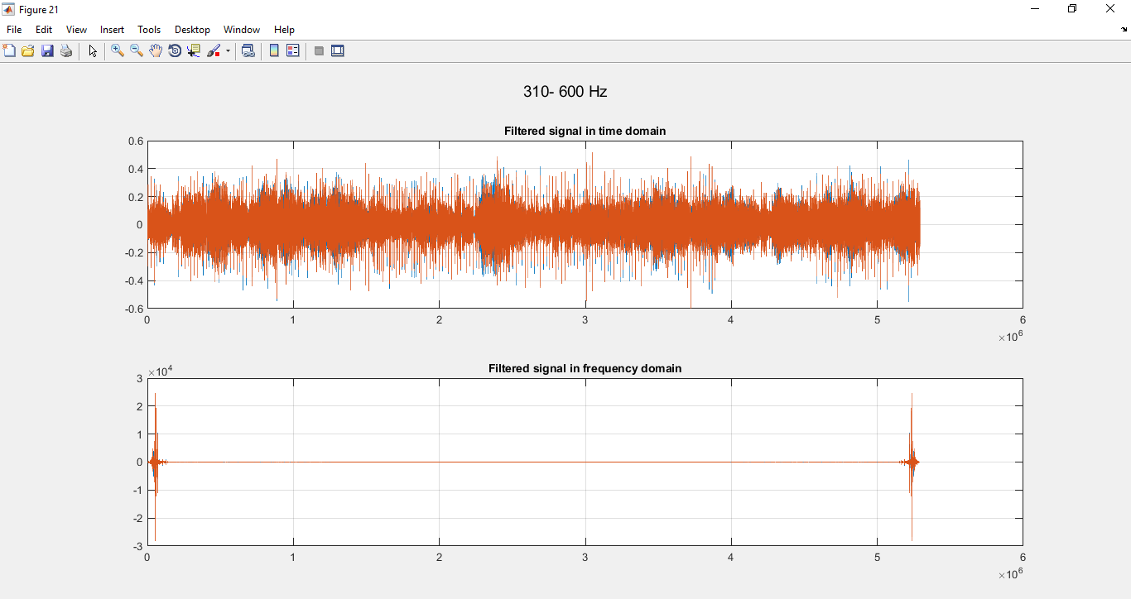Third Band 310-600 Hz:

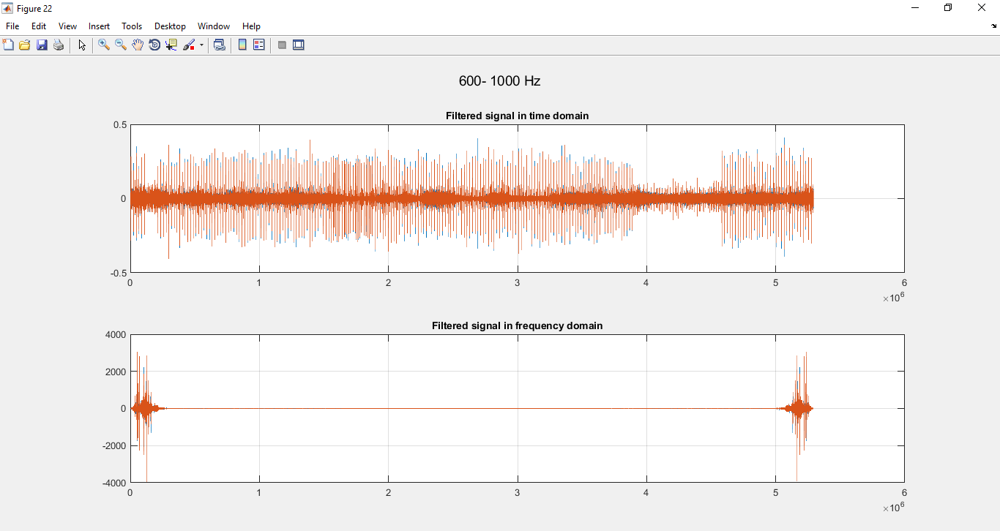Fourth Band 600-1000 Hz:

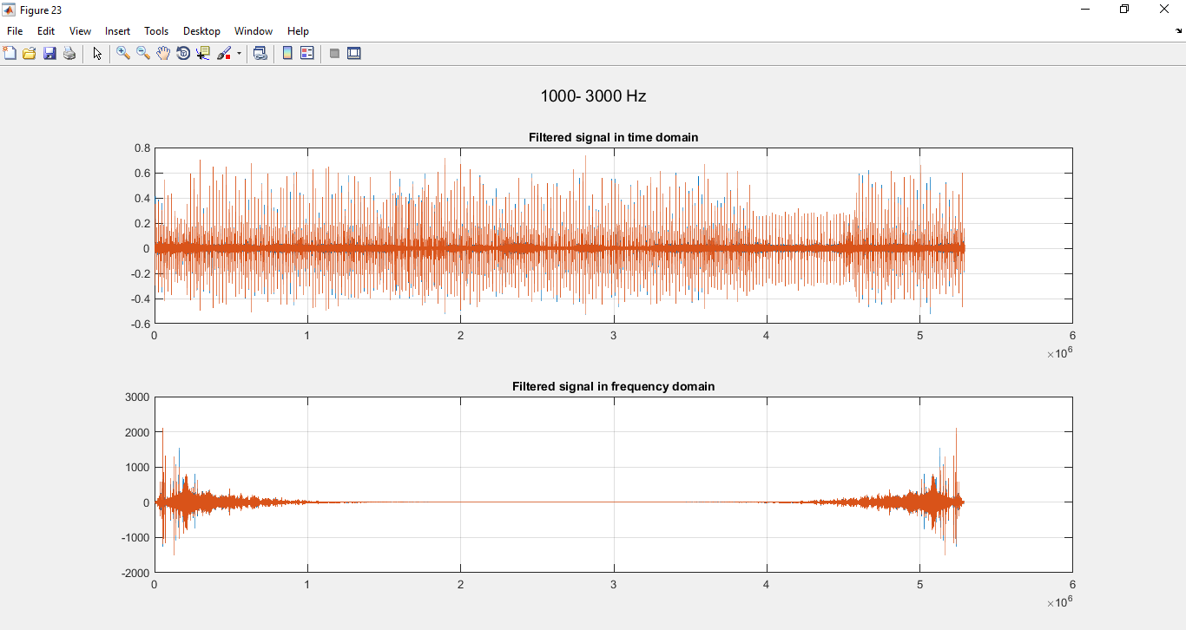Fifth Band 1000-3000 Hz:

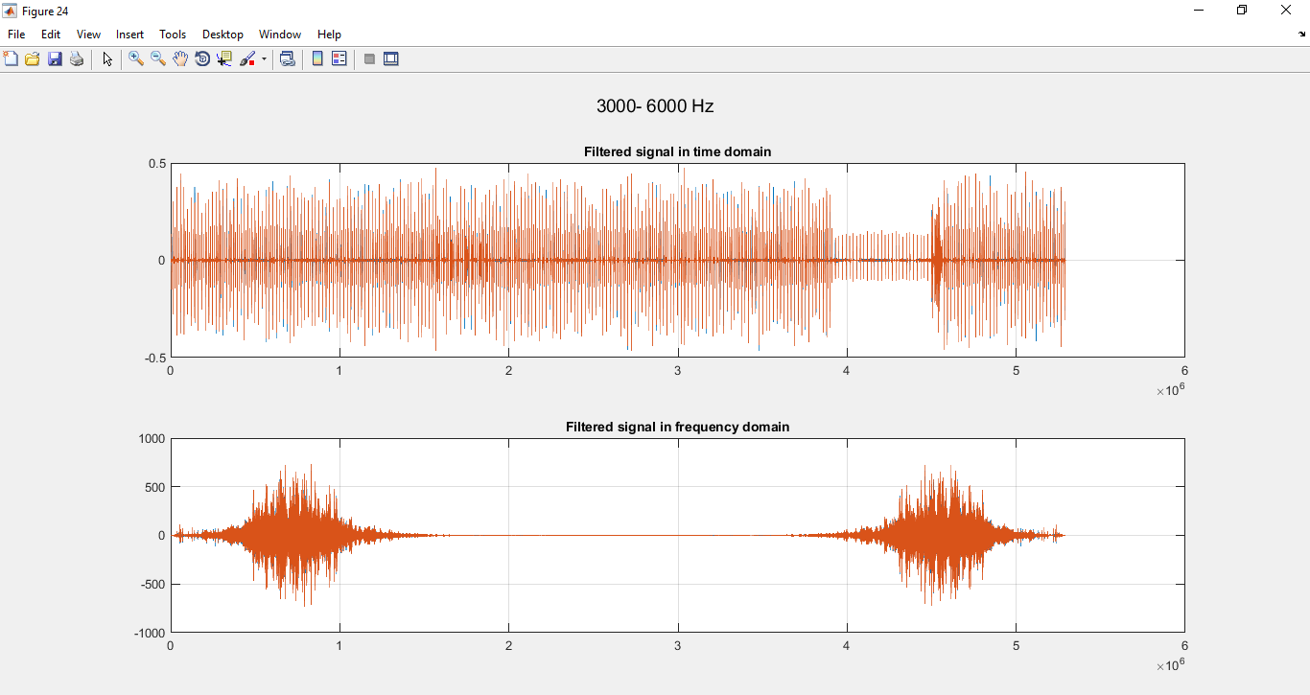Sixth Band 3000-6000 Hz:

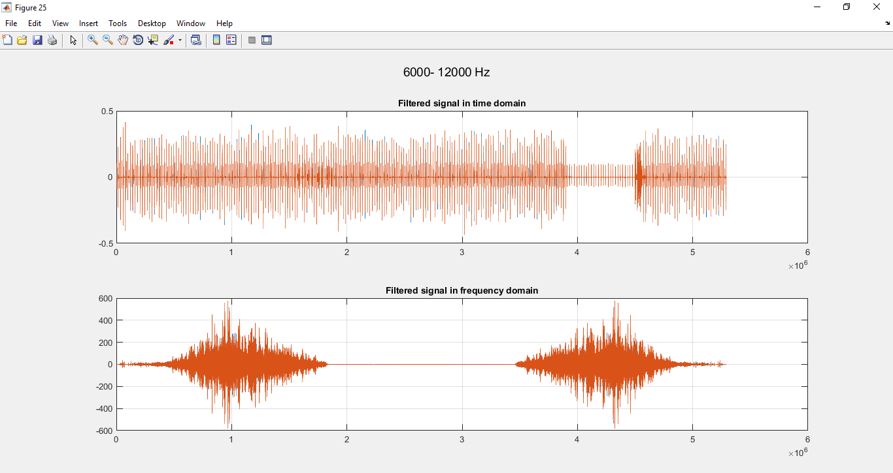Seventh Band 6000-12000 Hz:

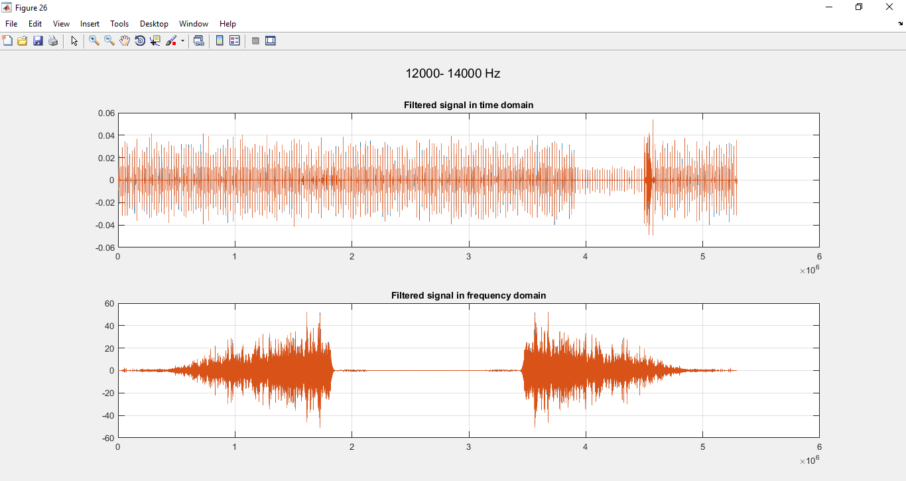Eighth Band 12000-14000 Hz:

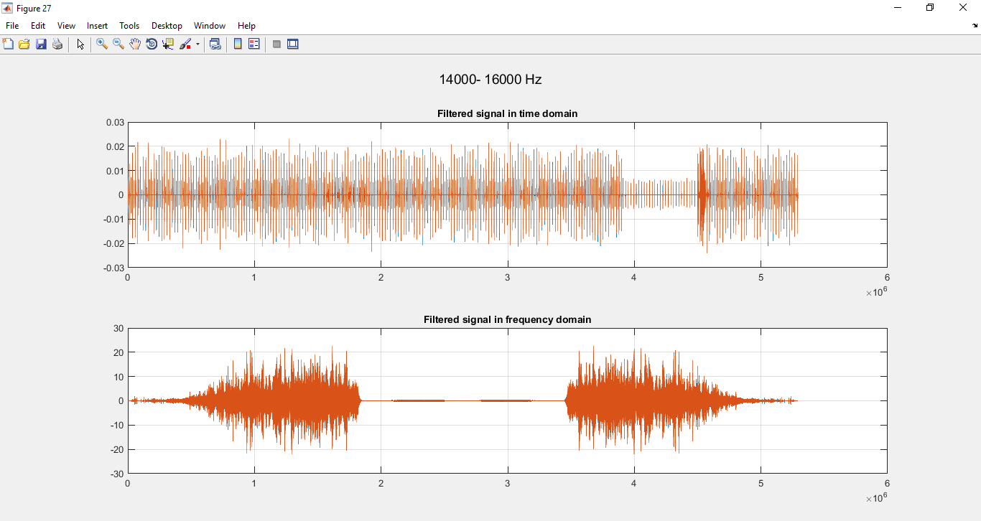Ninth Band 14000-16000 Hz:

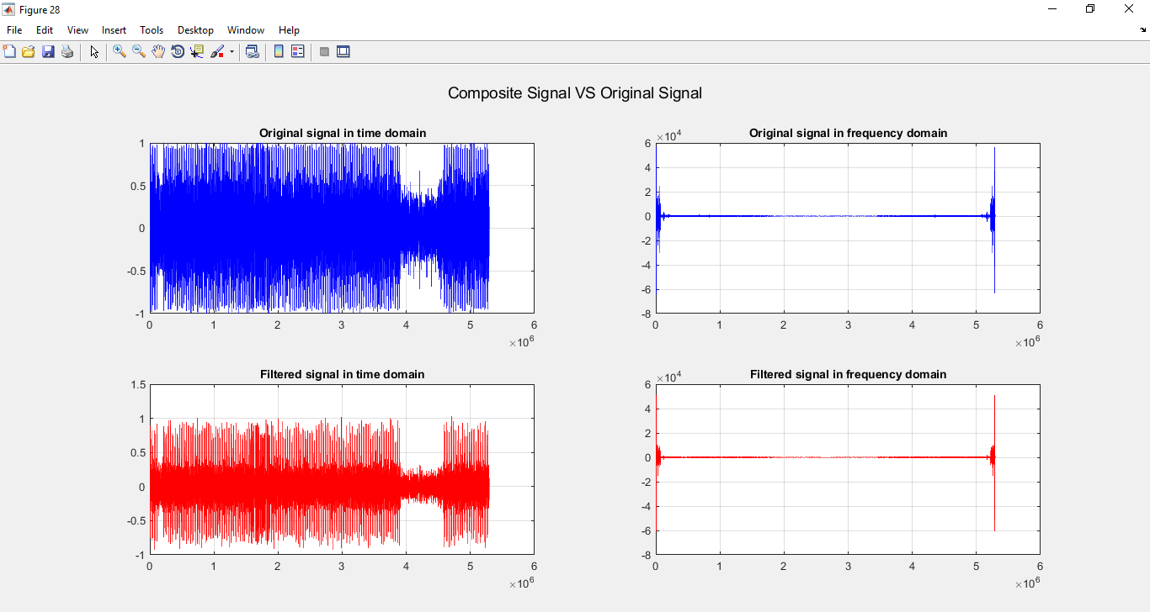**Output Signal**

-Second sample run:

* Sound File name is ‘sound2.wav’
* Gain = 0 for first 7 bands and = 5 for last 2 bands
* Output Sampling Frequency = 88200 (Double input Frequency Response)
* Type of filter is ‘FIR Filter’

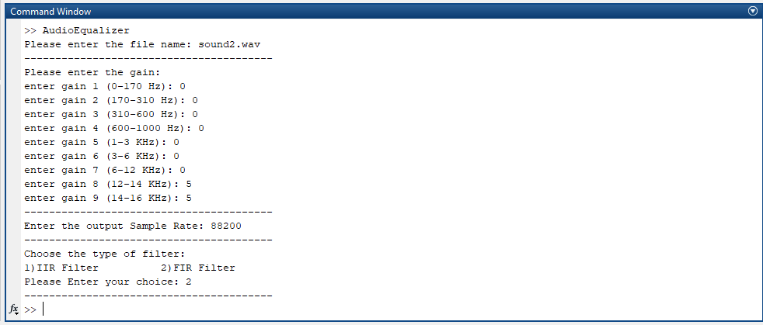

Analysis of each output and exported outputs

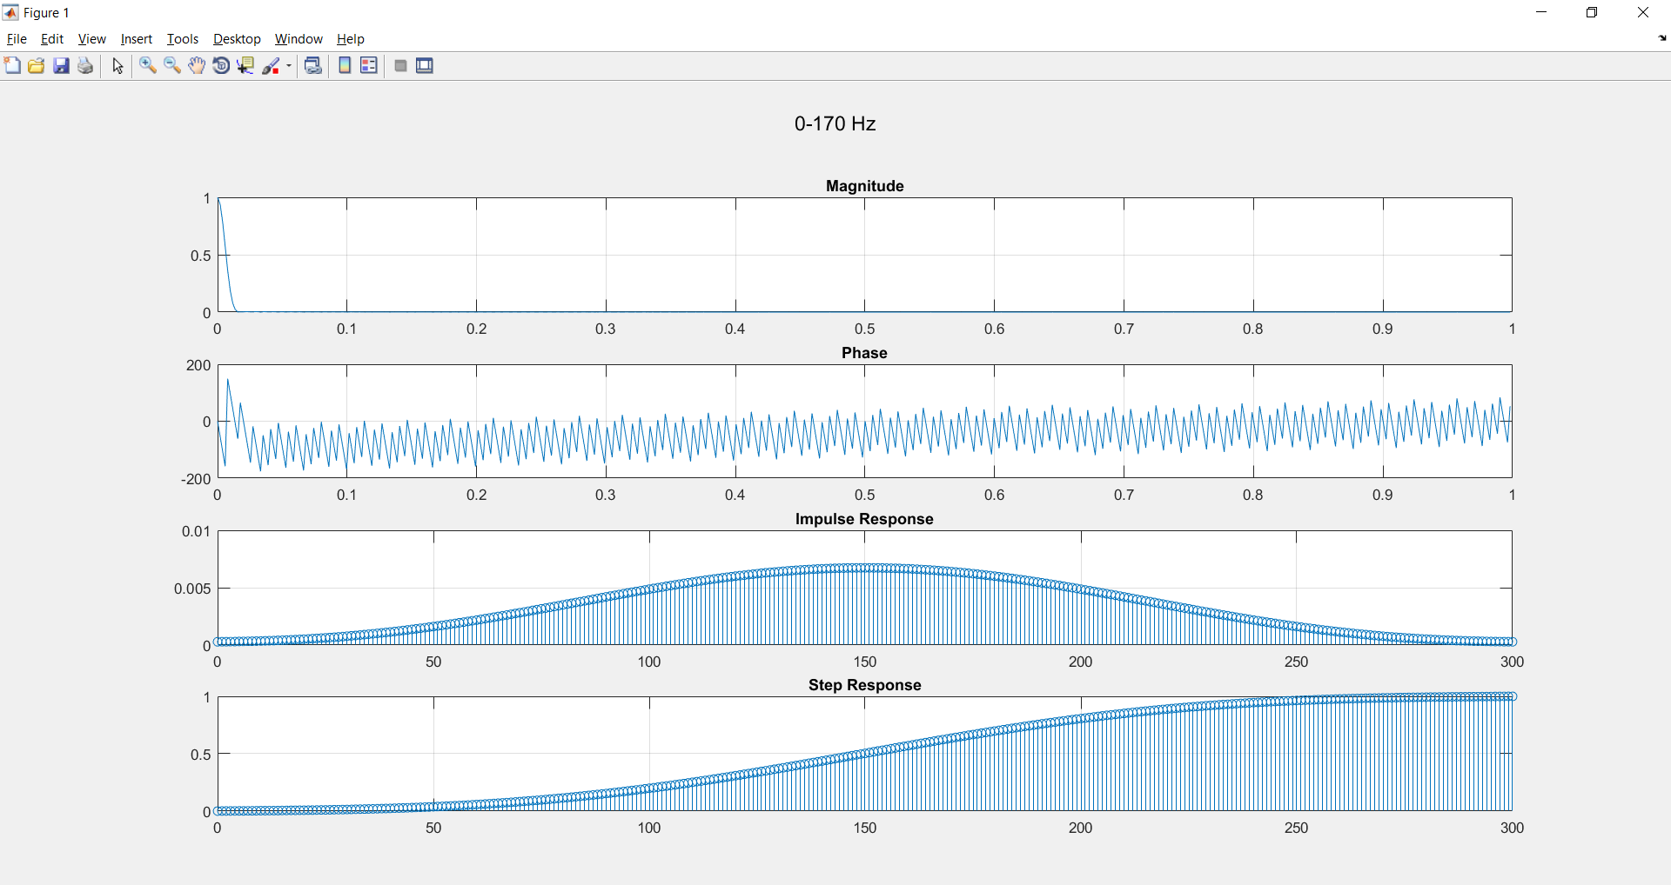First Band 0-170 Hz:

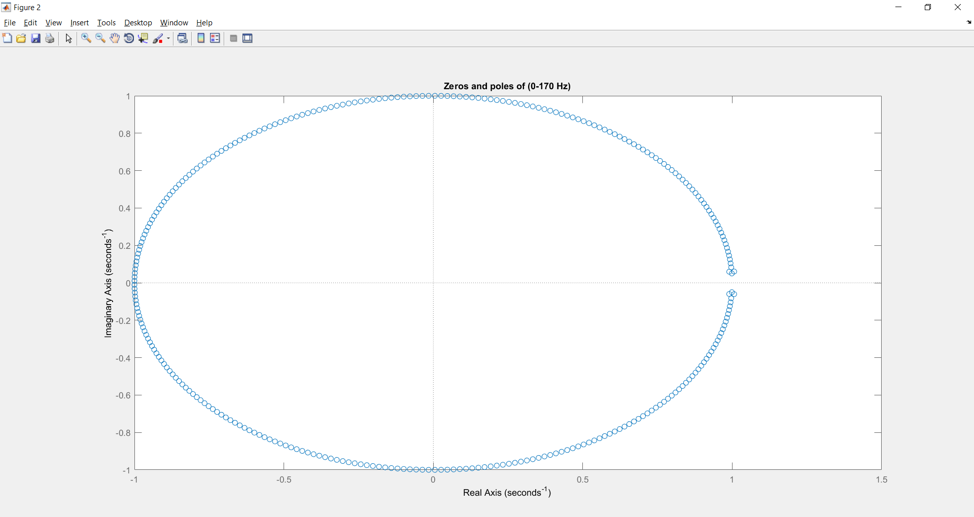

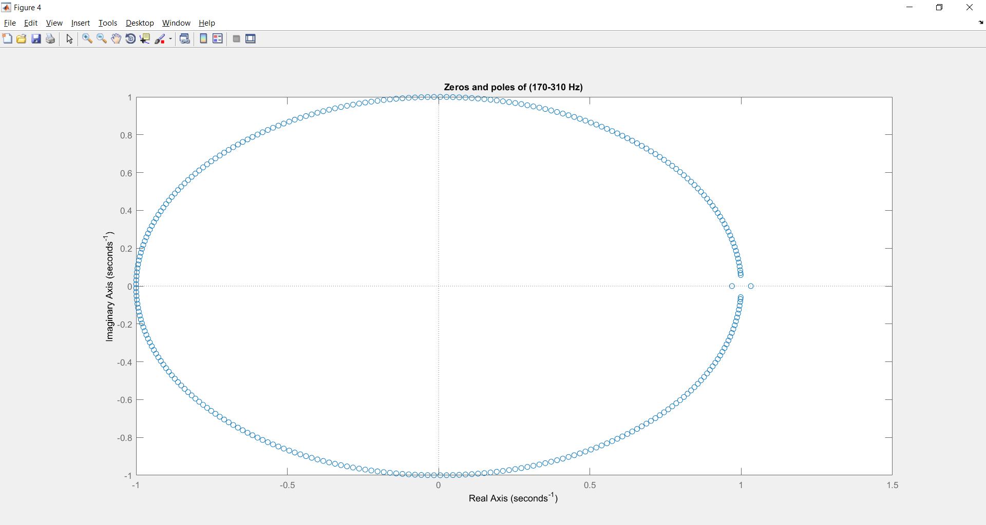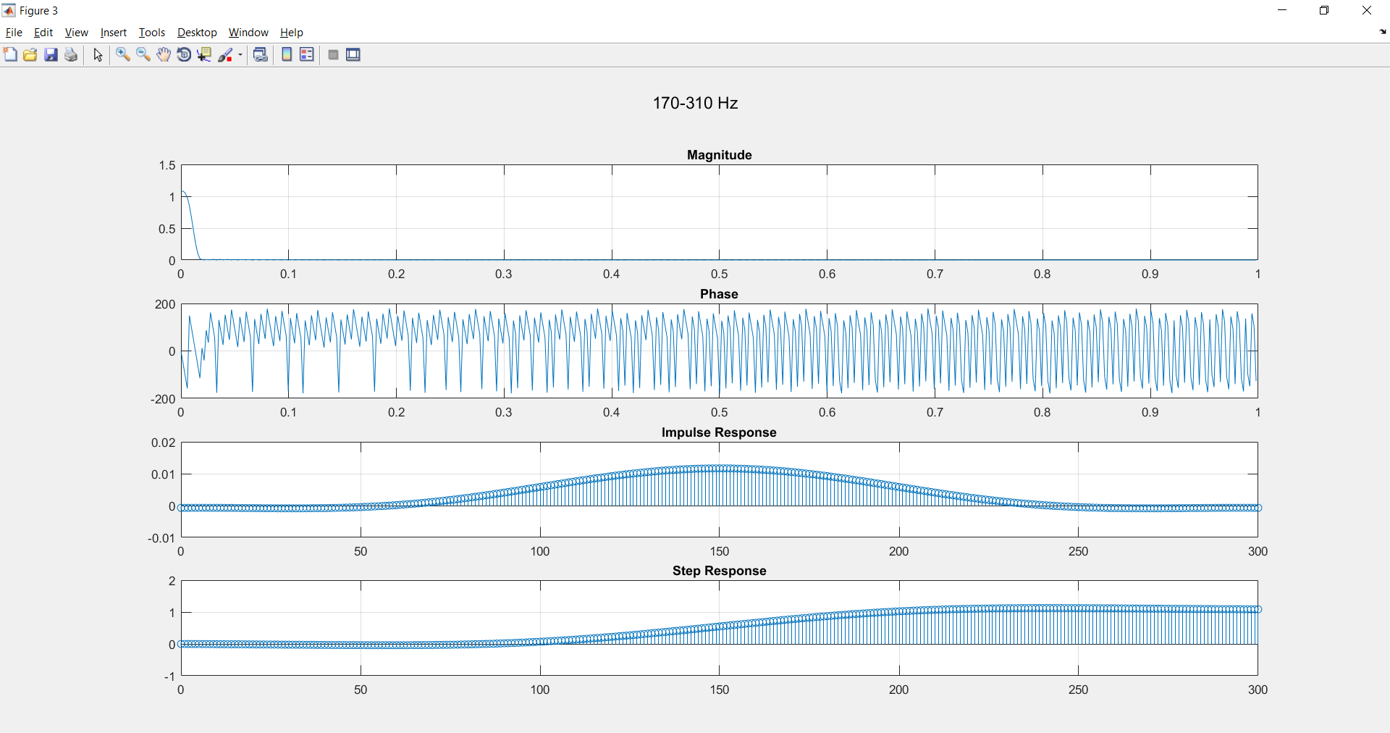Second Band 170-310 Hz:

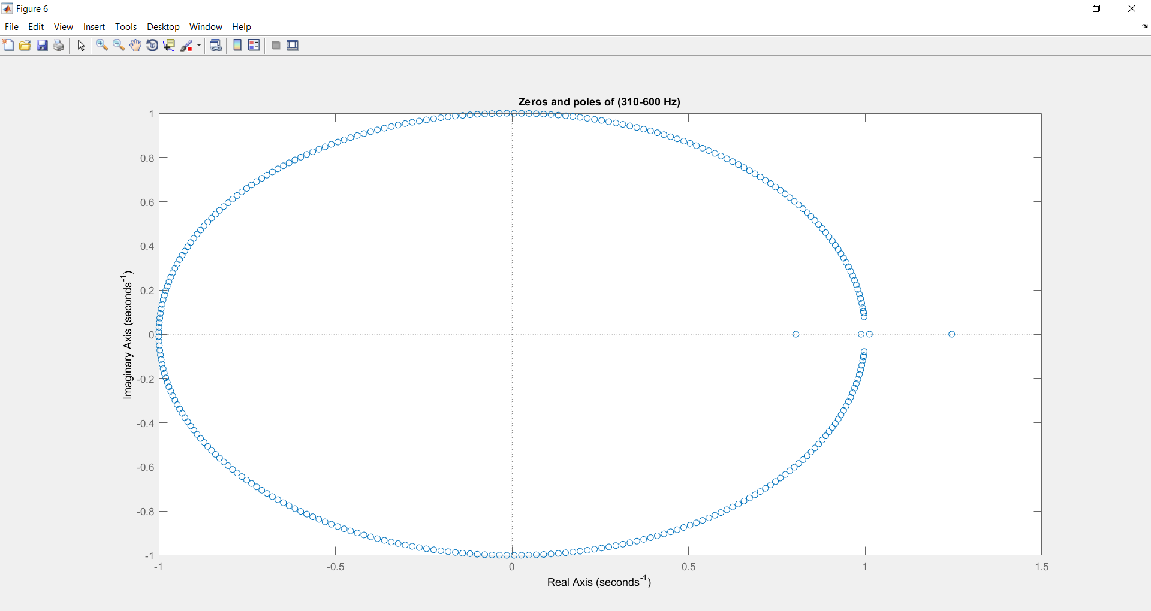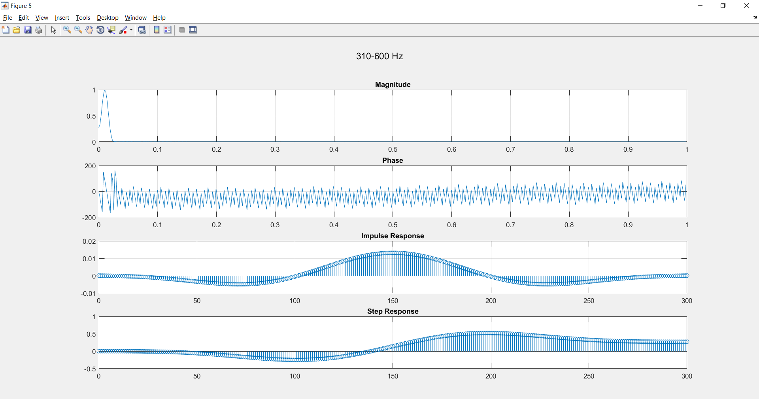Third Band 310-600 Hz:

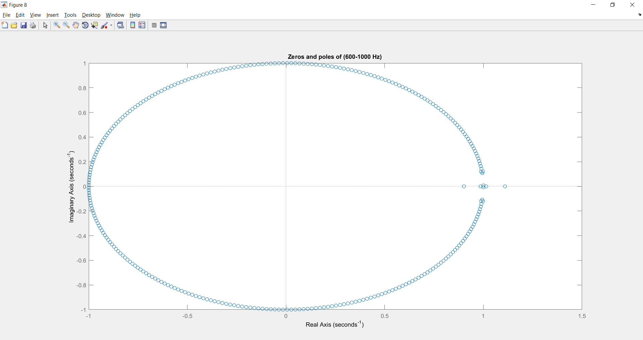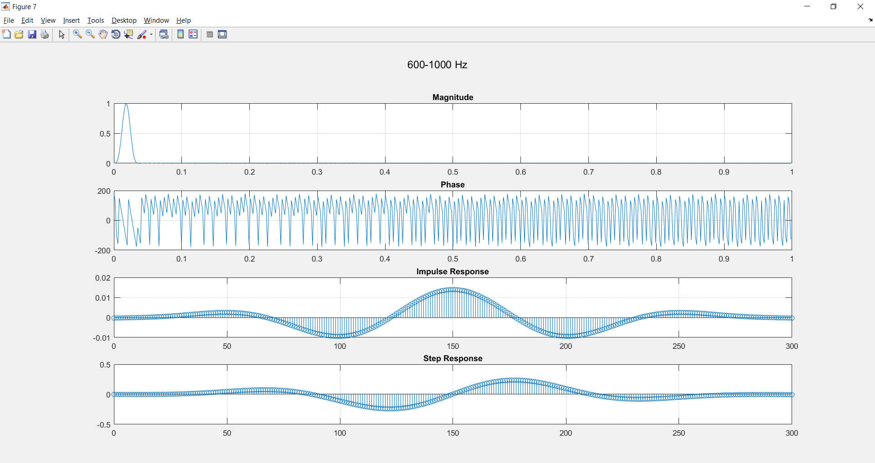 Fourth Band 600-1000 Hz:

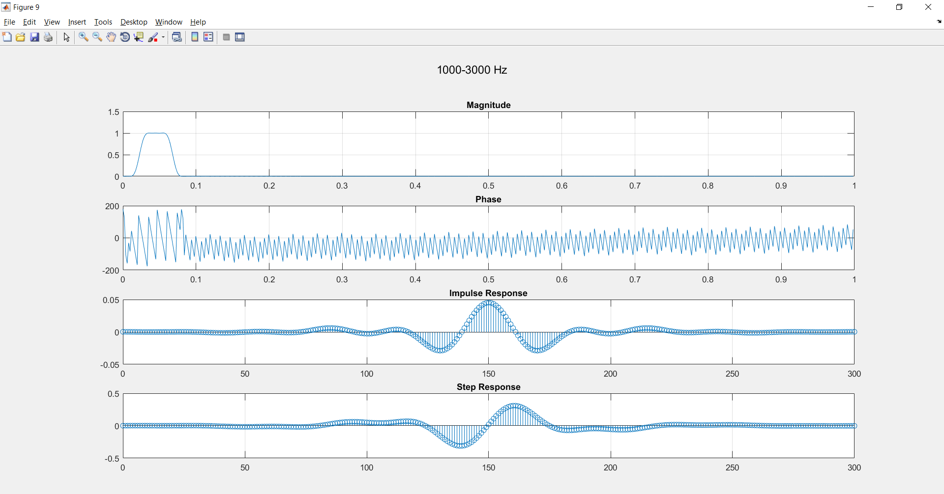Fifth Band 1000-3000 Hz:

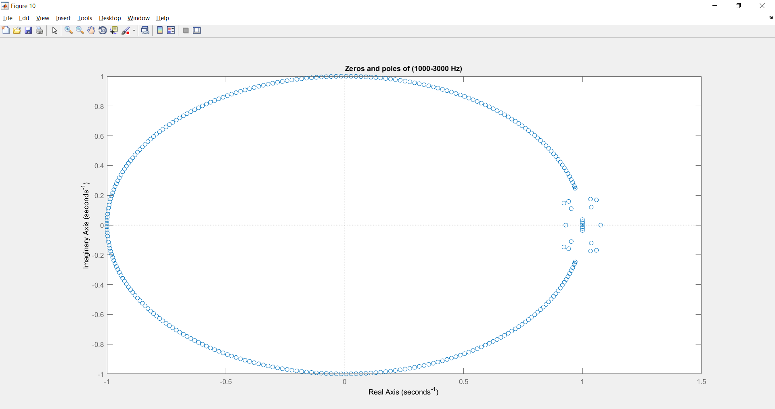

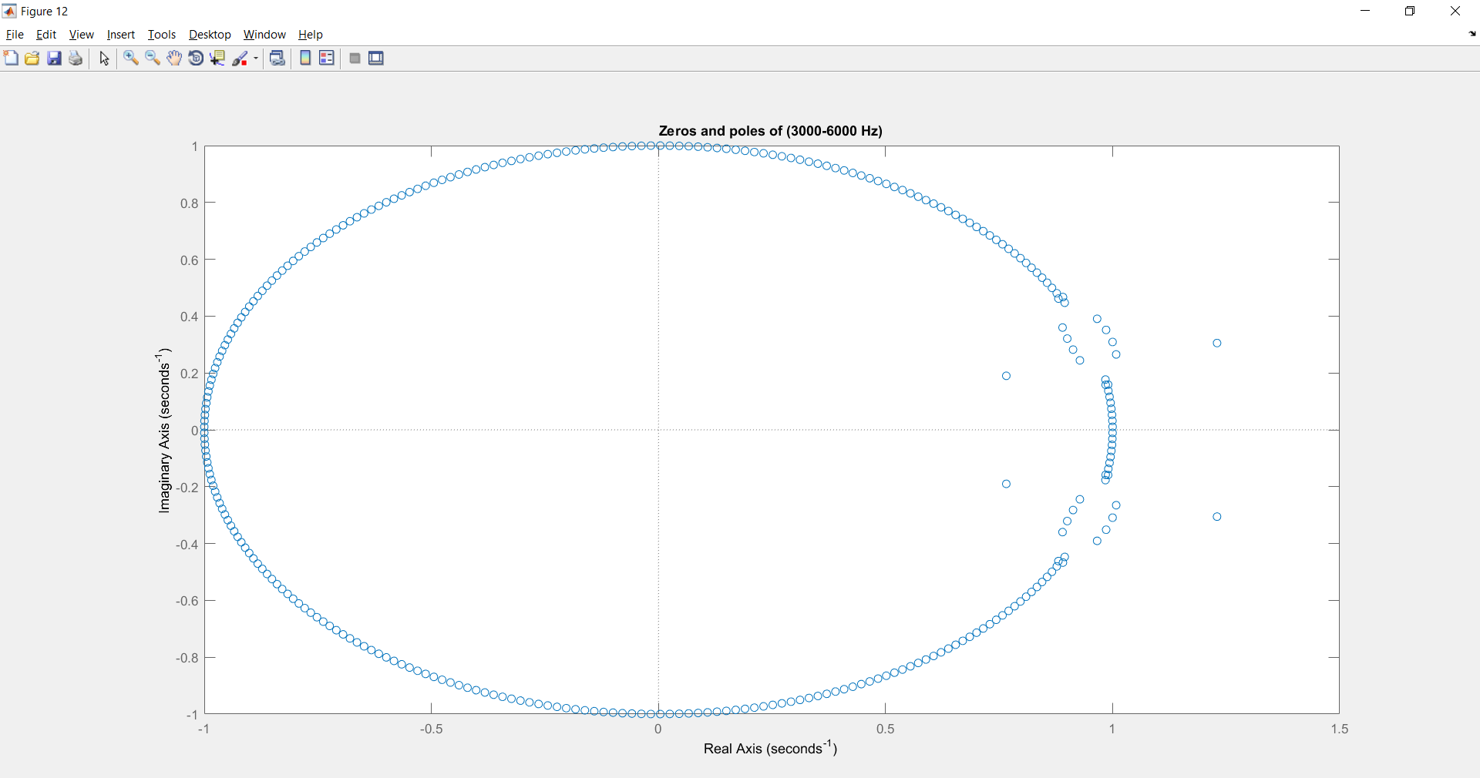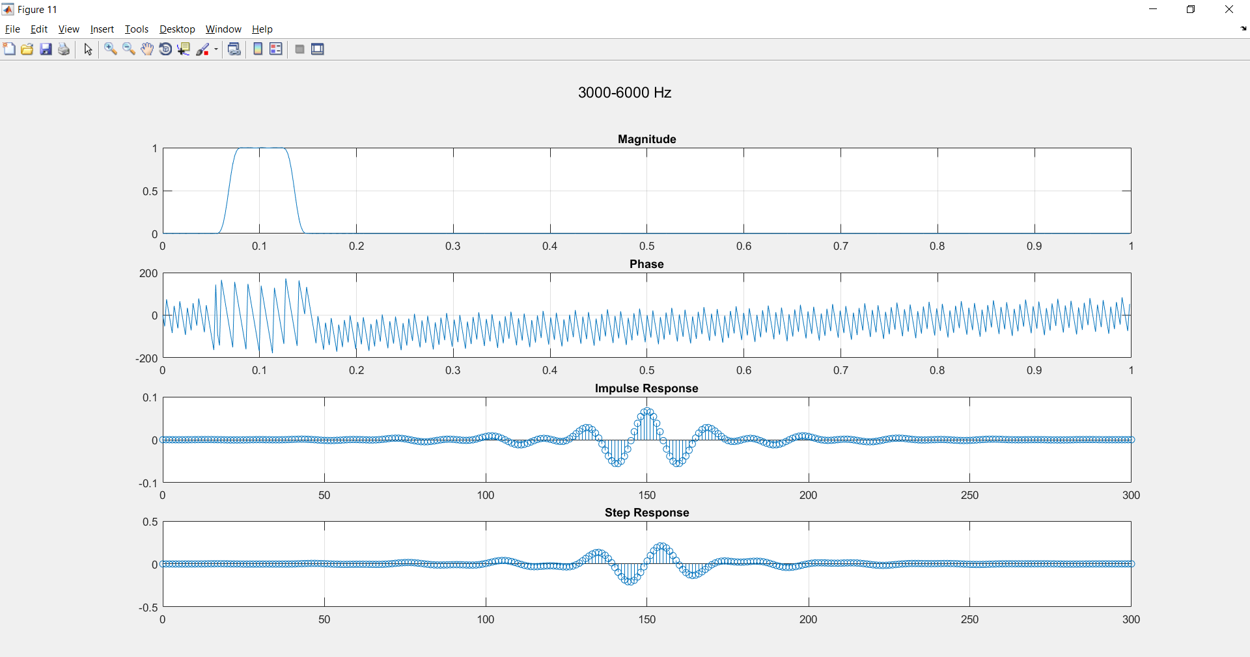Sixth Band 3000-6000 Hz:

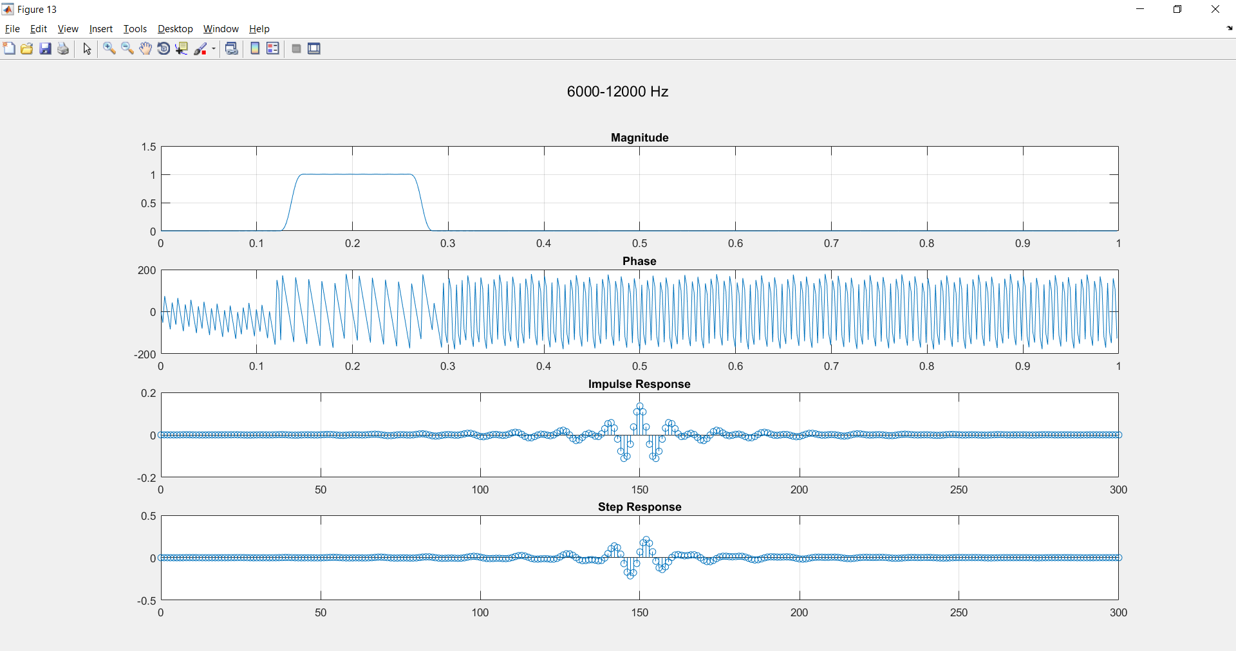Seventh Band 6000-12000 Hz:

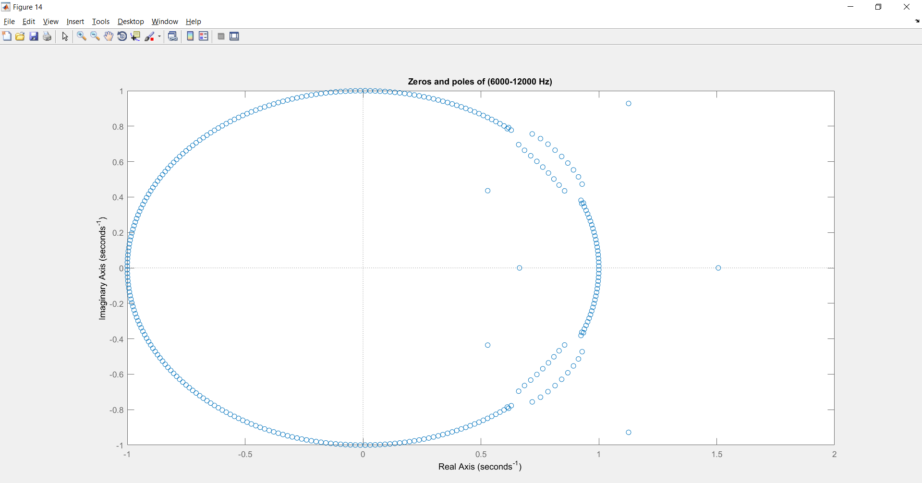

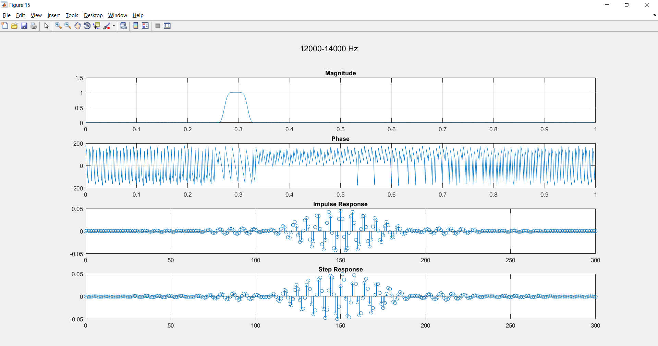Eighth Band 12000-14000 Hz:

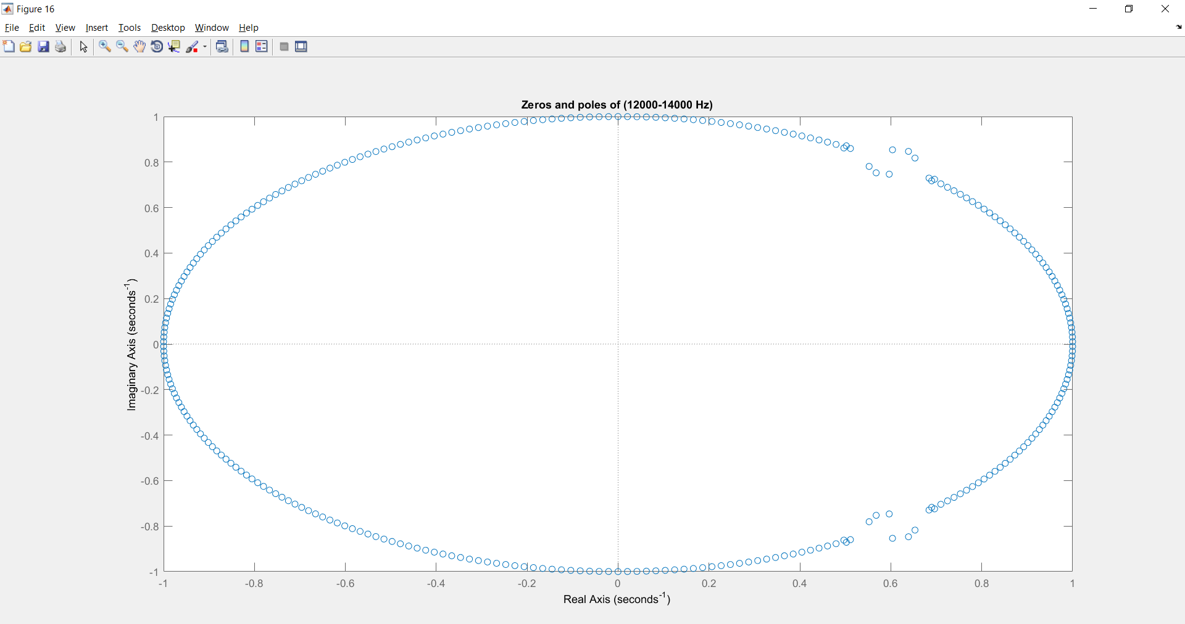

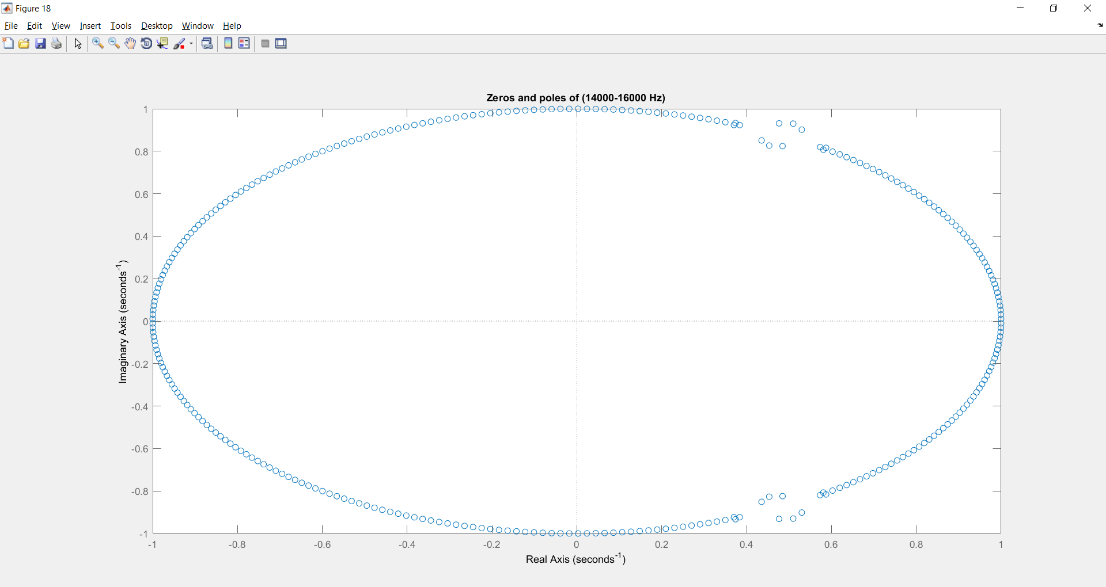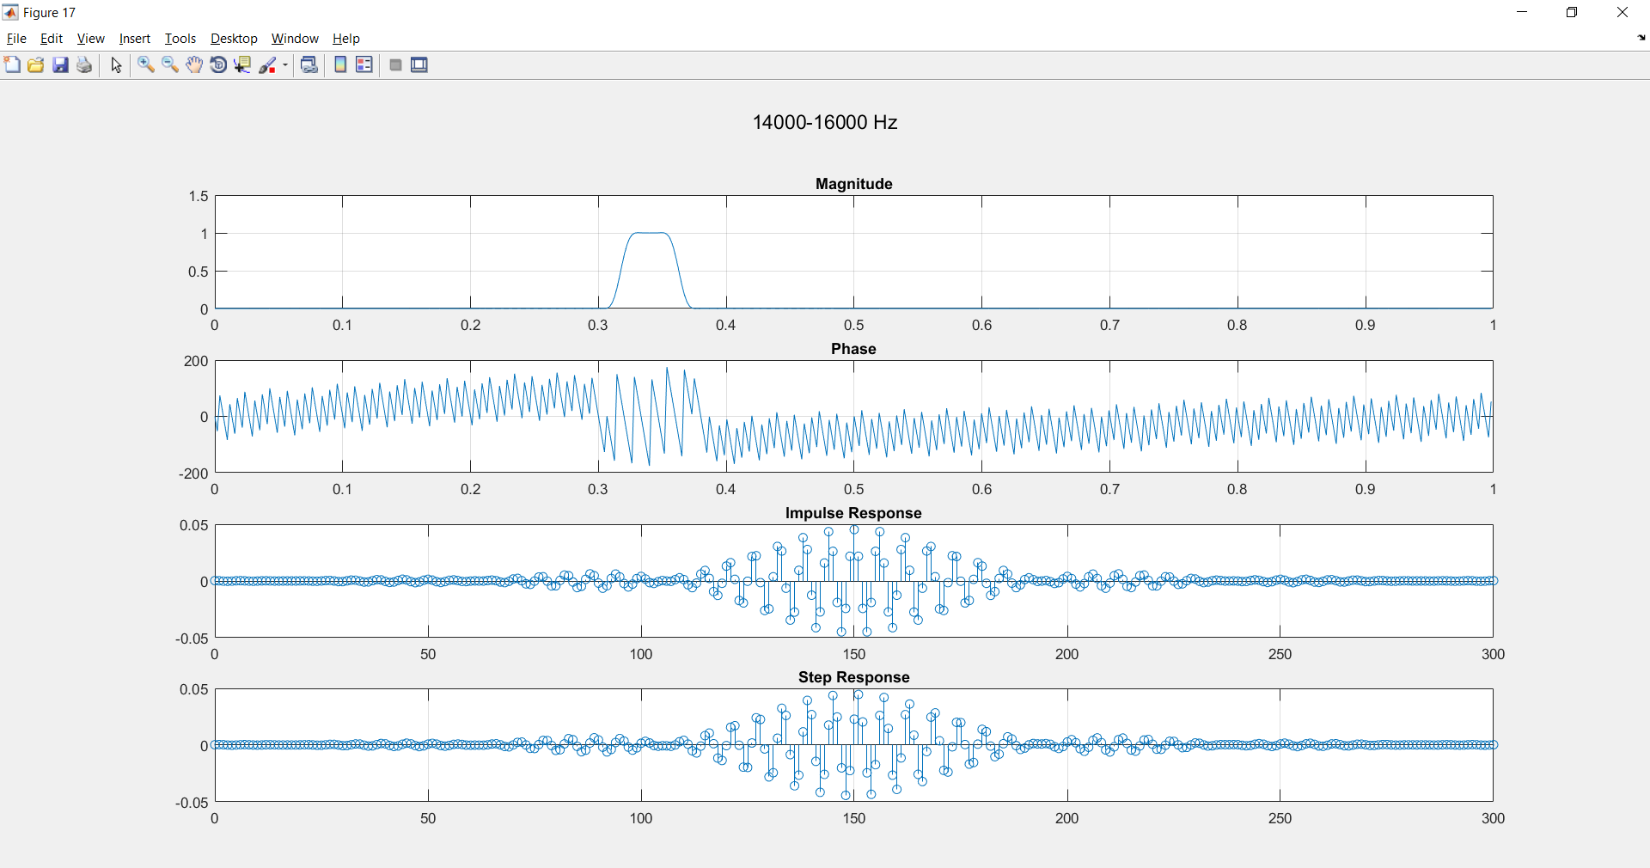Ninth Band 14000-16000 Hz:

All Signals in Frequency and Time Domain

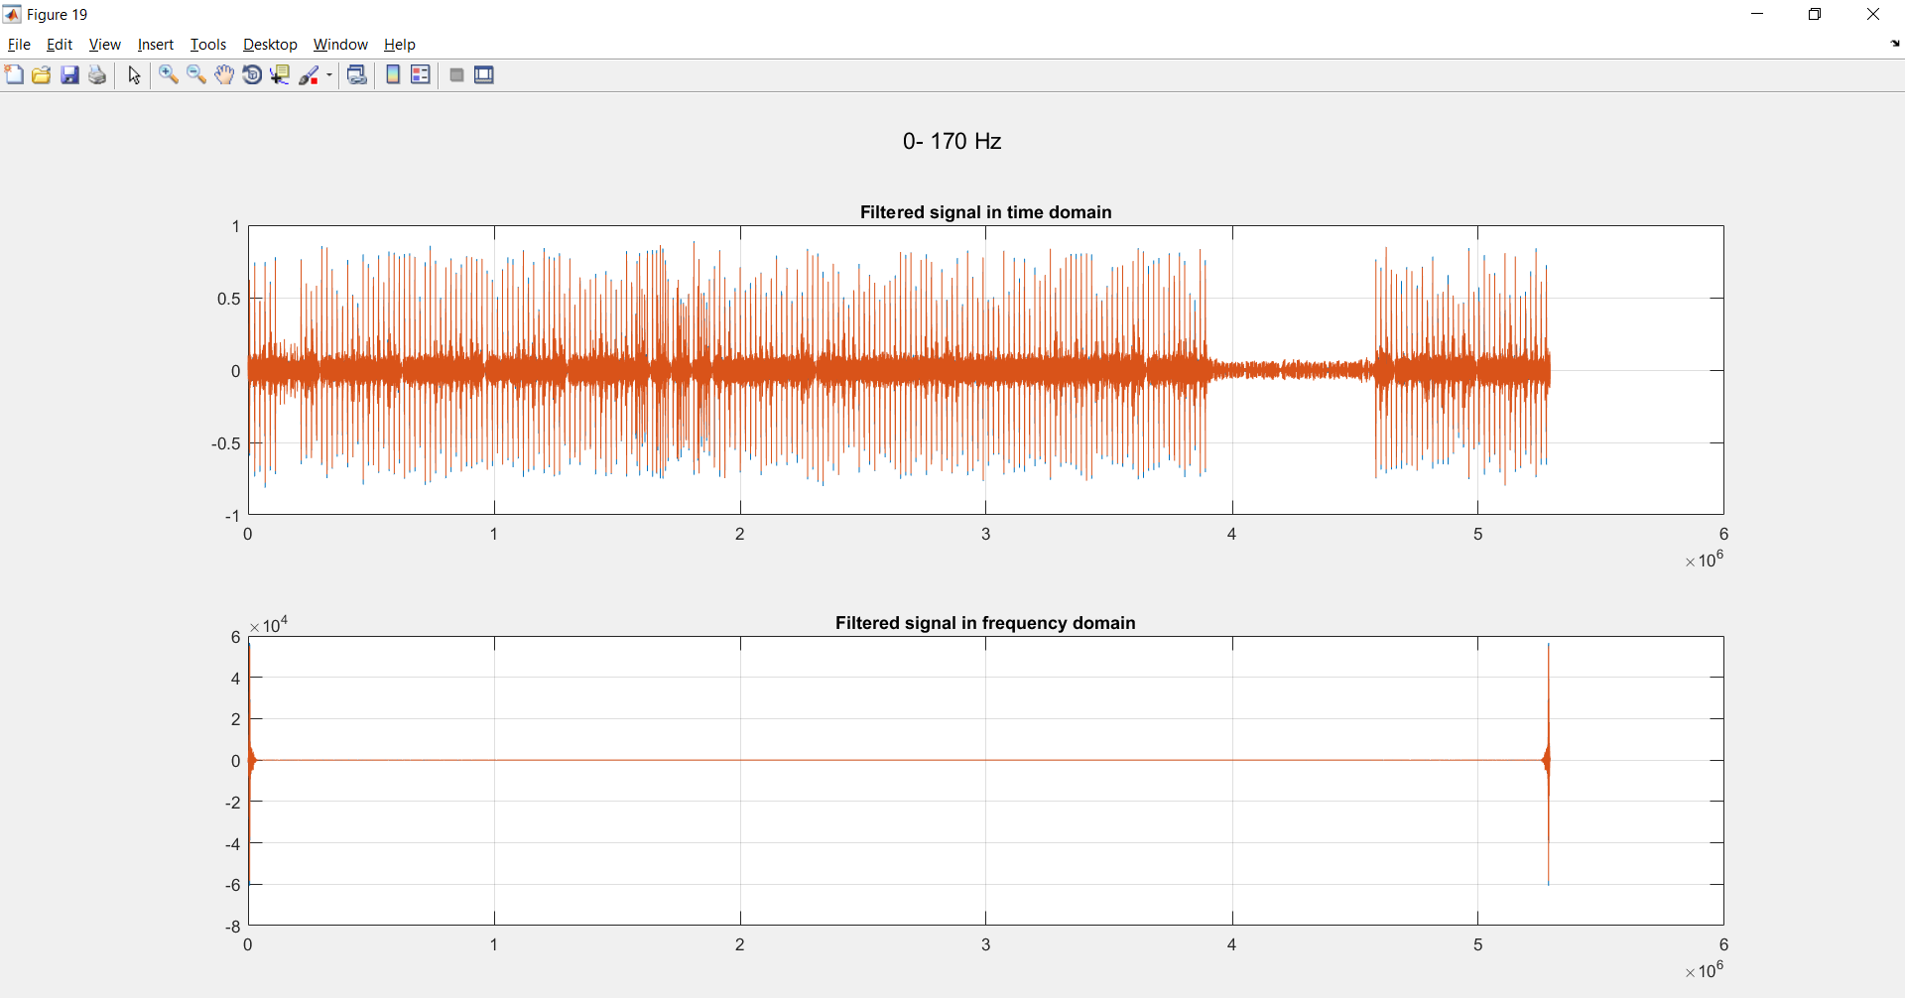First Band 0-170 Hz:

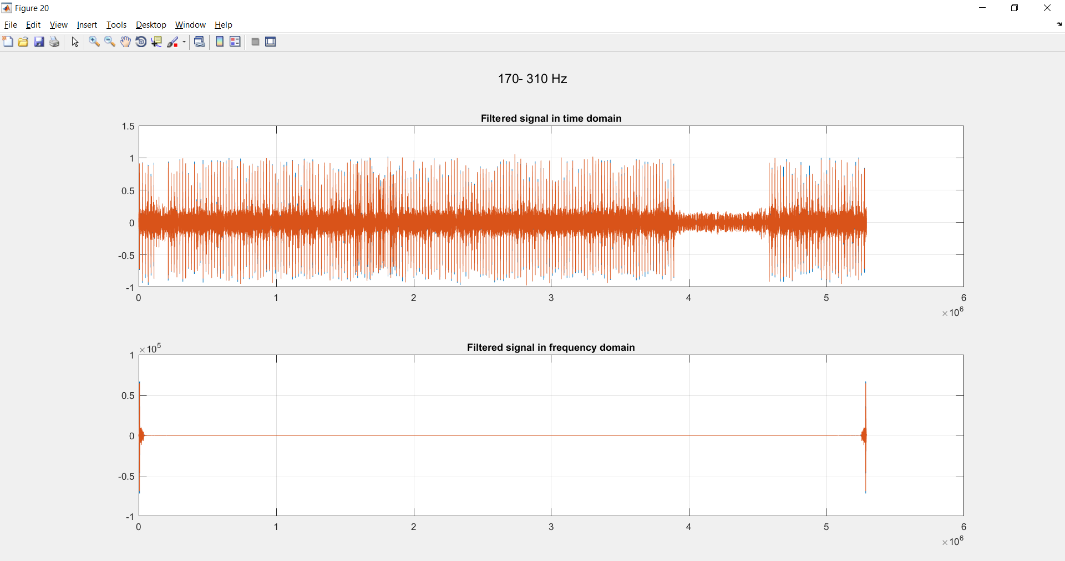Second Band 170-310 Hz

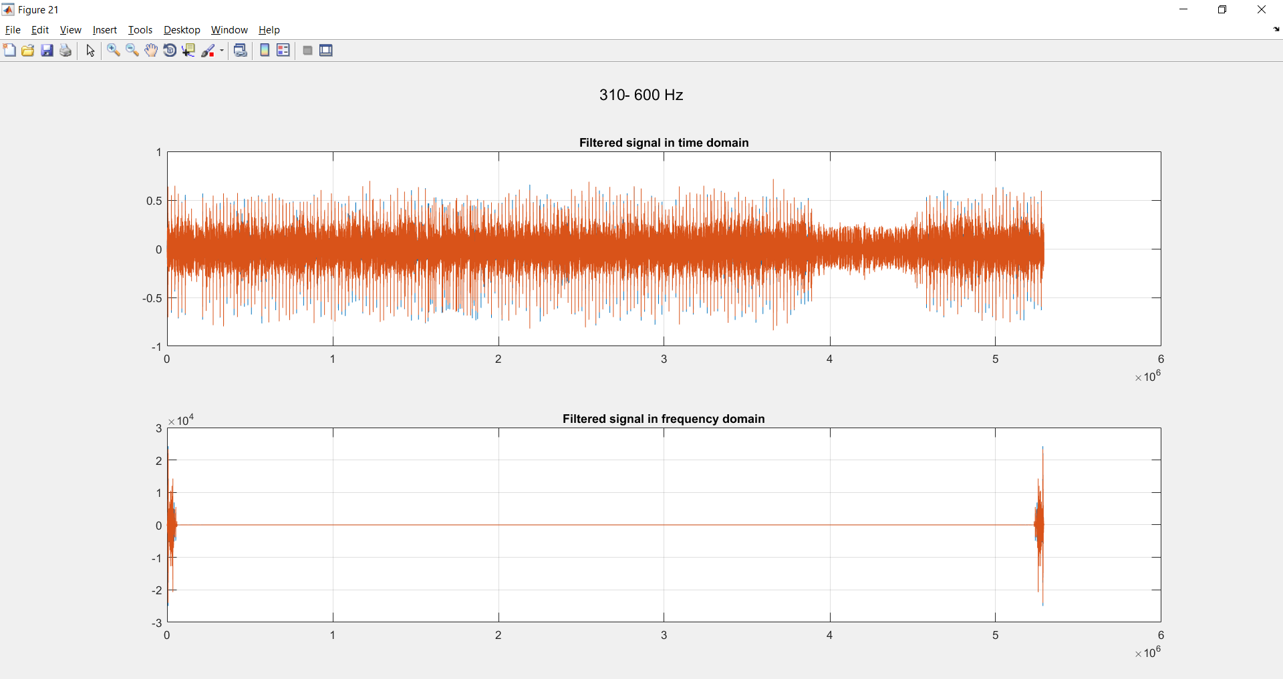Third Band 310-600 Hz:

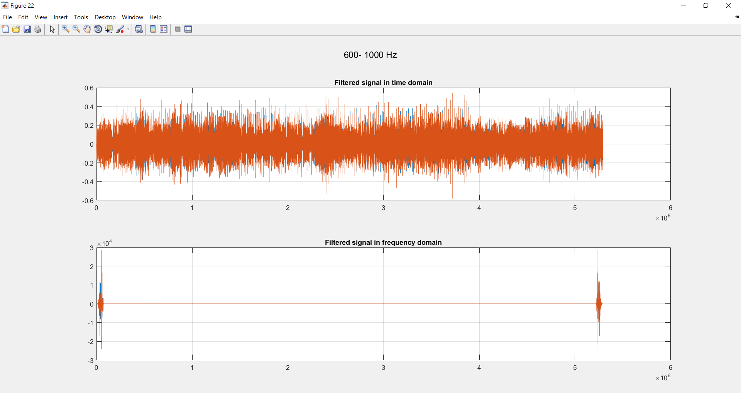Fourth Band 600-1000 Hz:

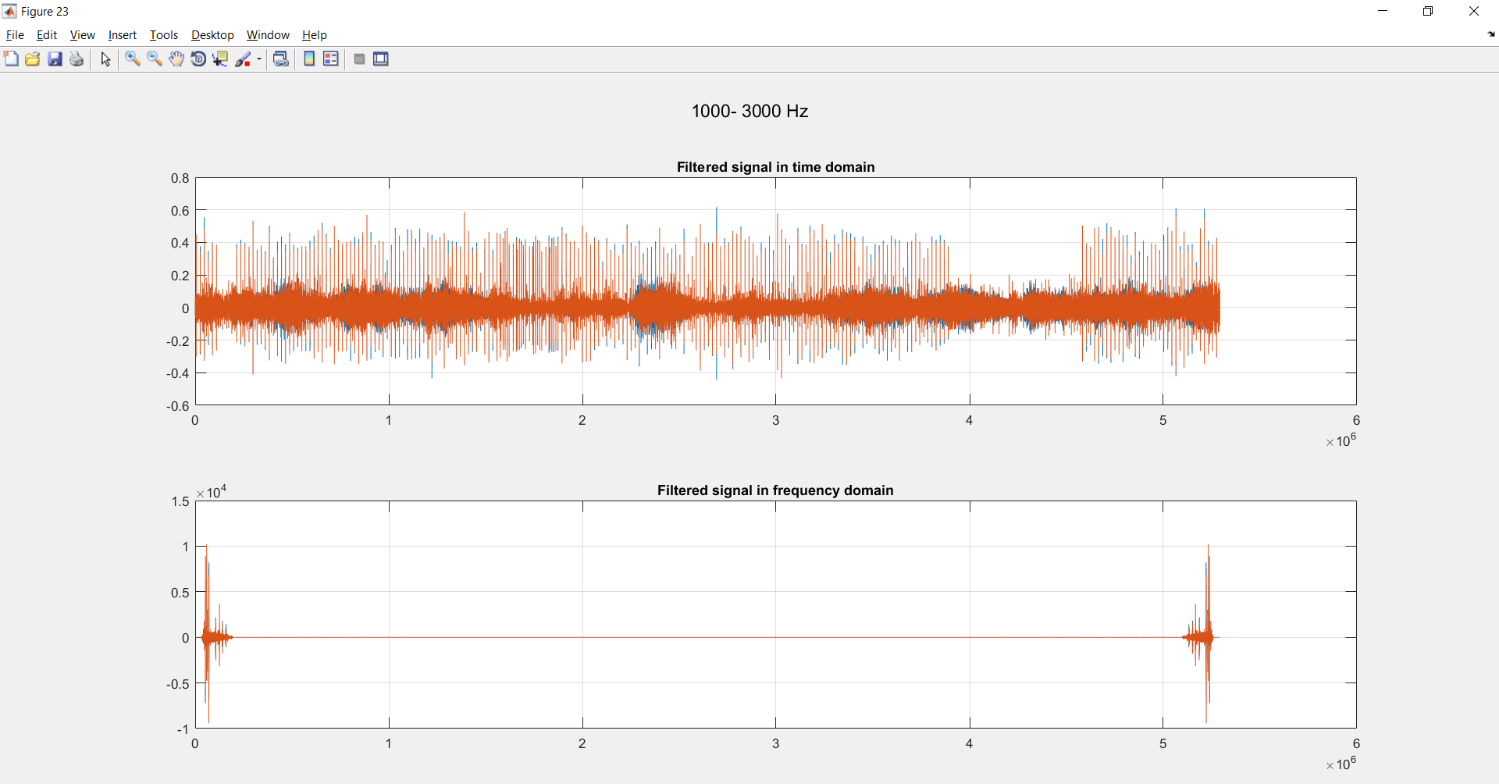Fifth Band 1000-3000 Hz:

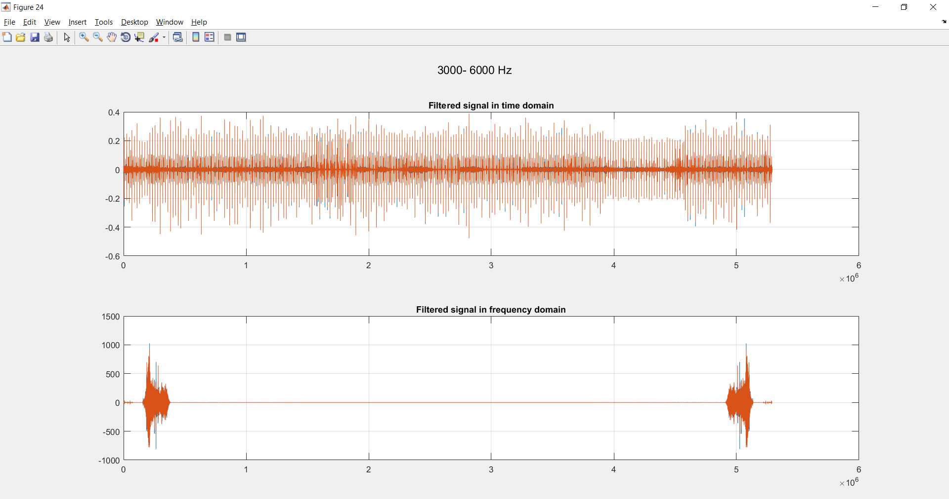Sixth Band 3000-6000 Hz:

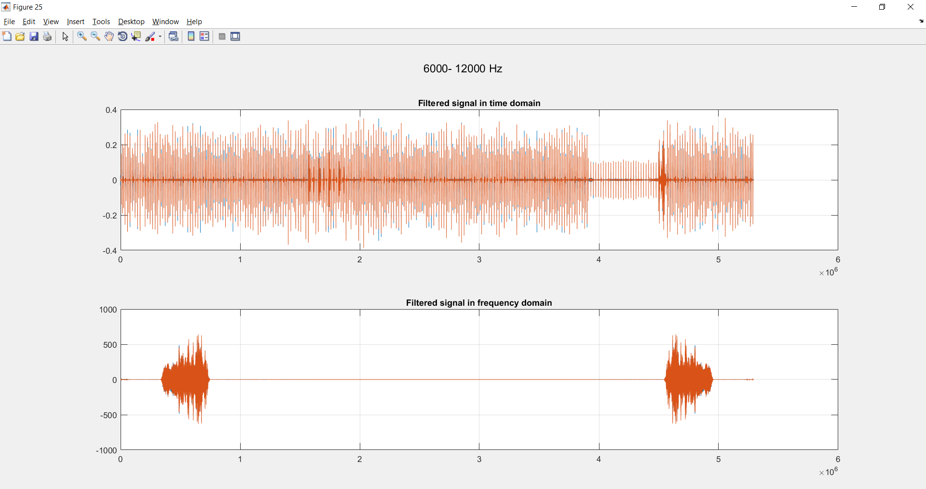Seventh Band 6000-12000 Hz:

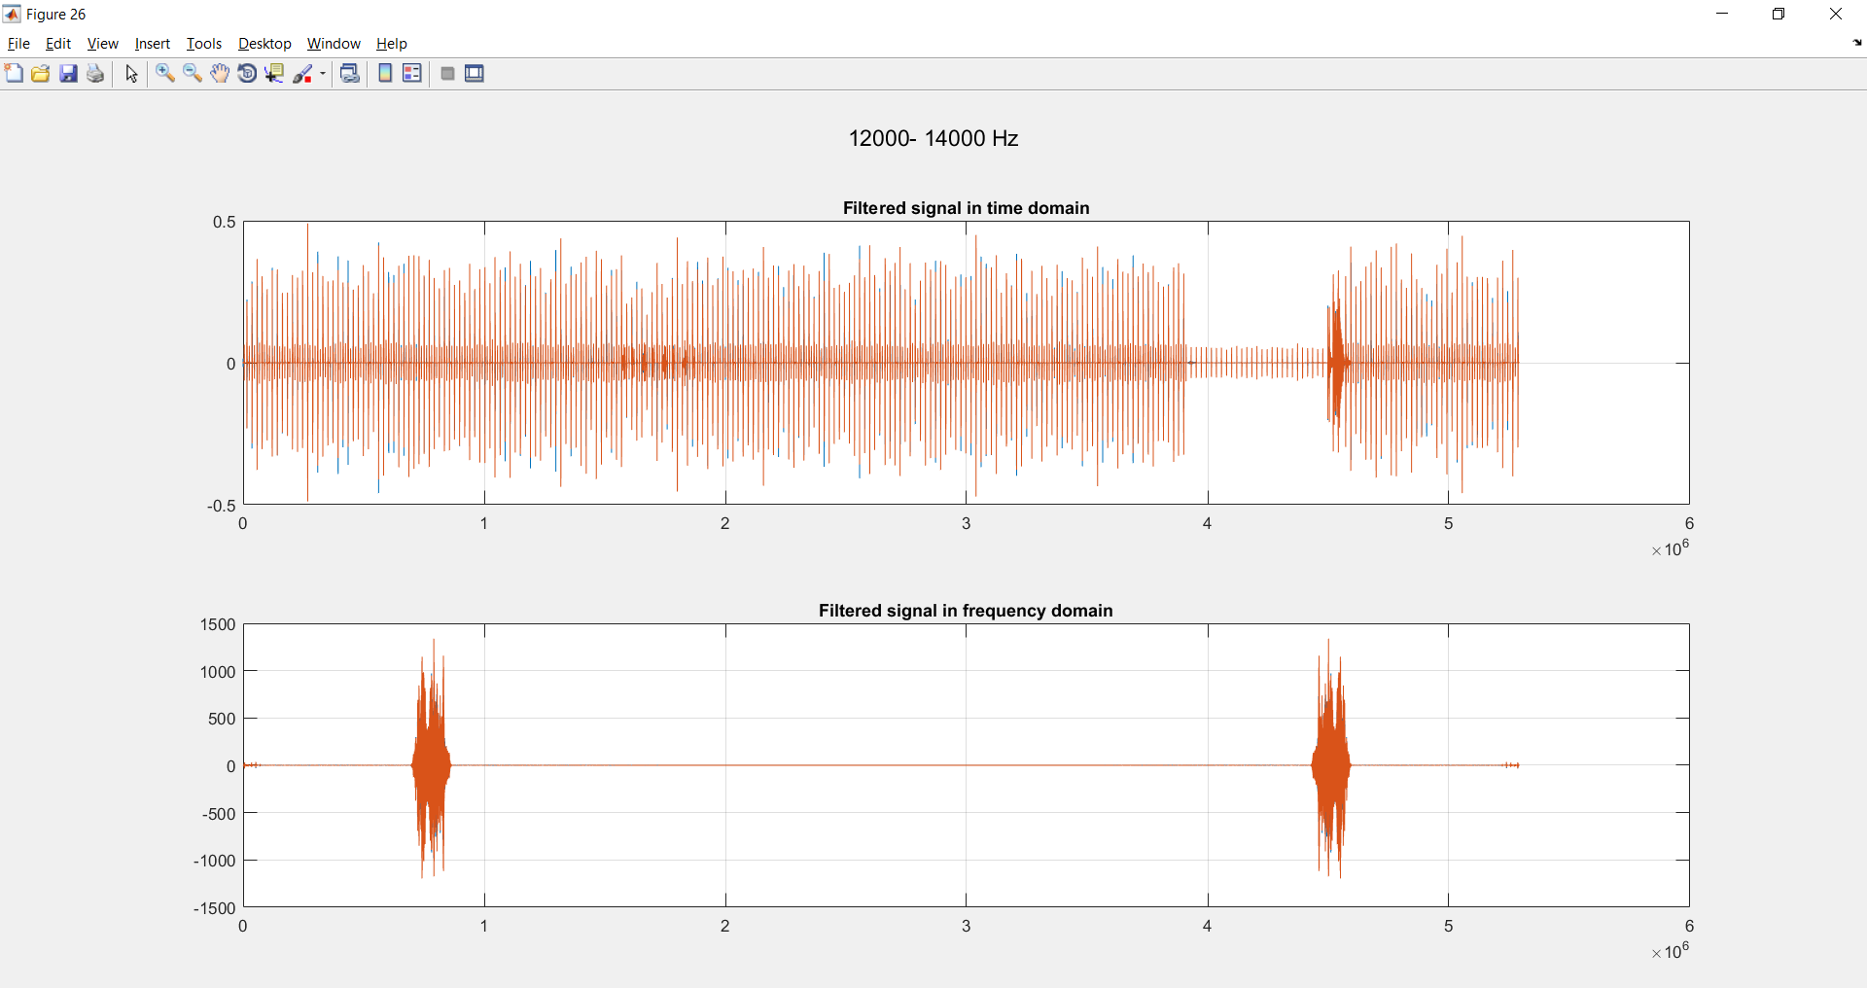Eighth Band 12000-14000 Hz:

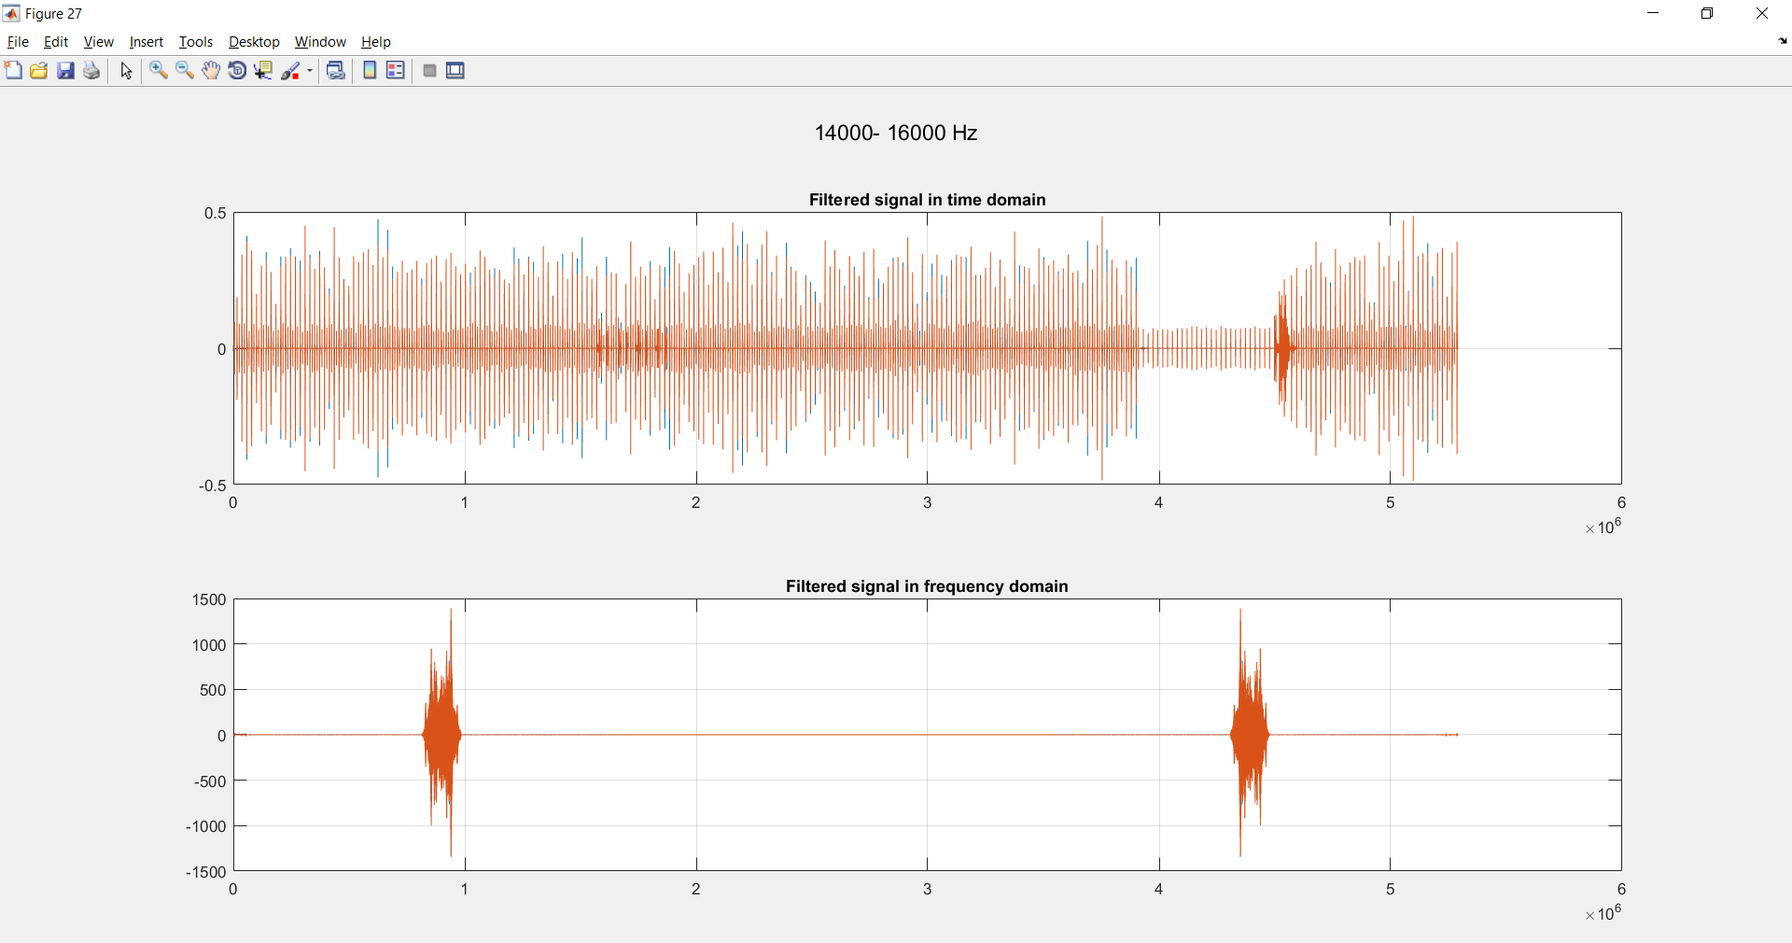Ninth Band 14000-16000 Hz:

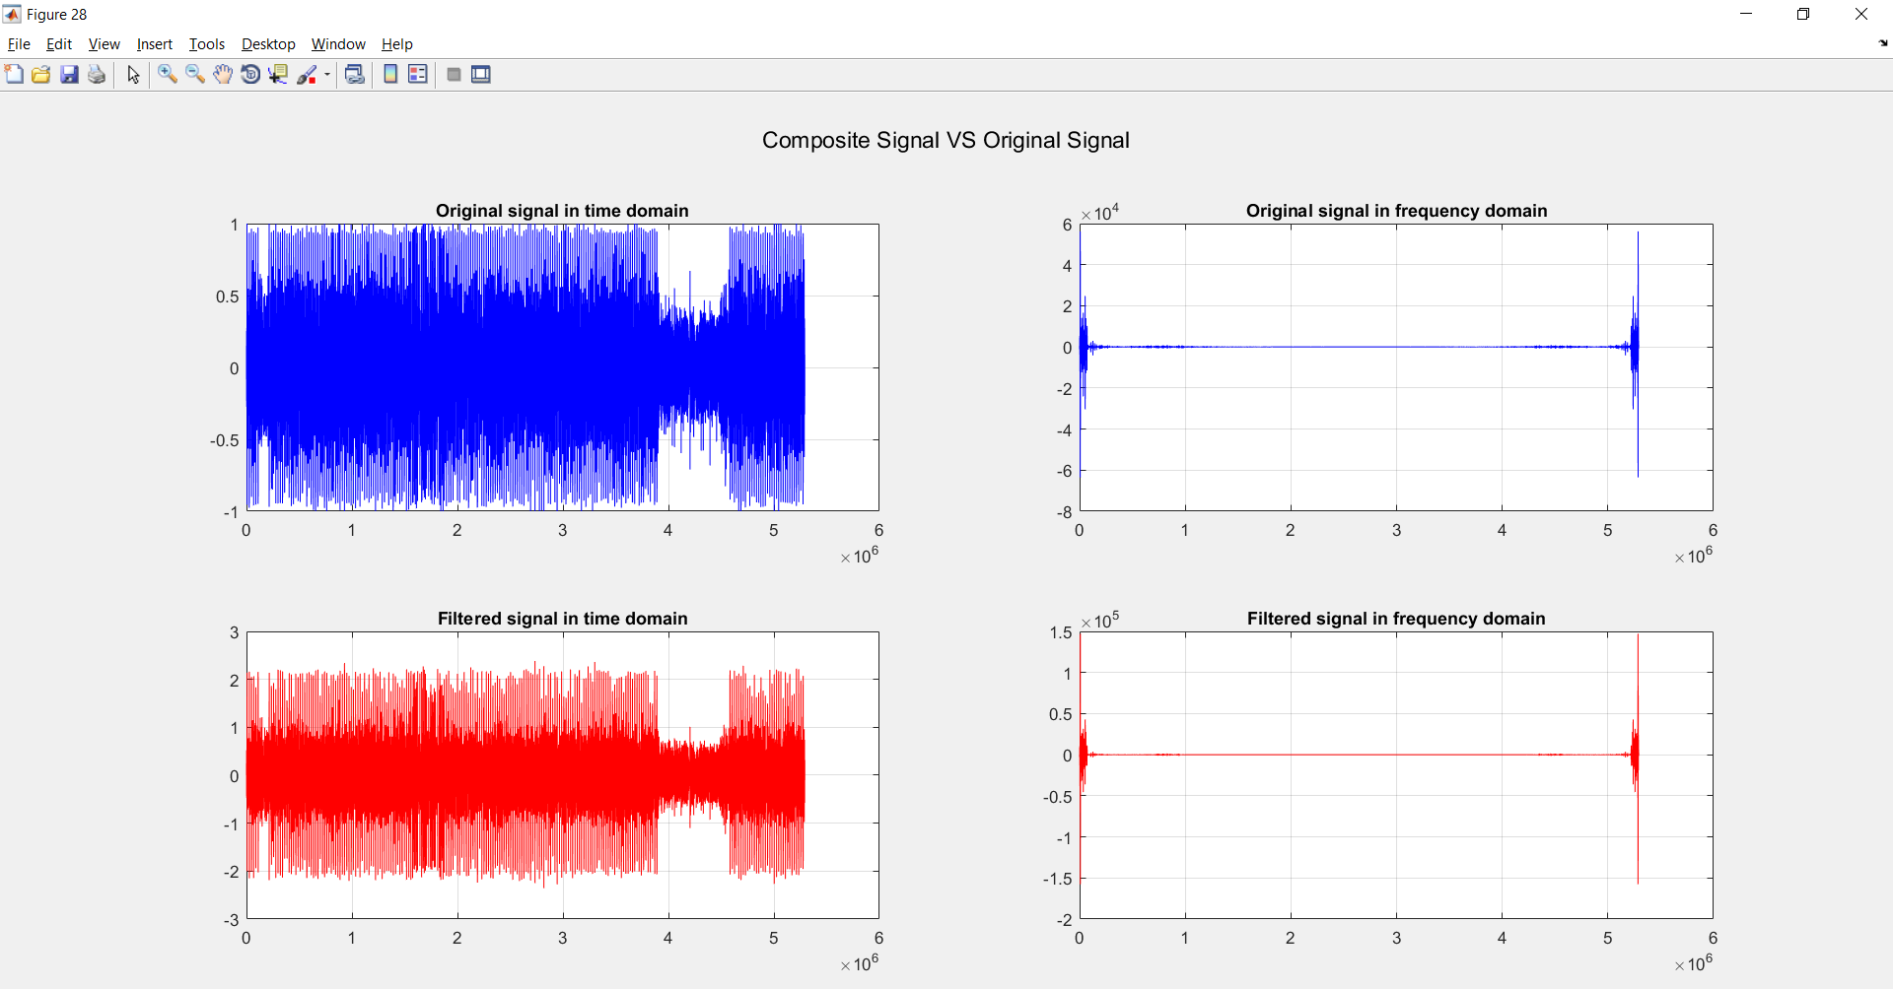**Output Signal**